**MINISTRY OF EDUCATION AND TRAINING**

**FPT UNIVERSITY**

Capstone Project Document

**Job Searching System**

|  |  |
| --- | --- |
| **Group JSS** | |
| **Group members** | Huỳnh Đức Tài – Leader – SE60630  Nguyễn Ngọc Thiện – Member – SE90129  Phạm Quốc Thái – Member – SE60599  Võ Hoàn Thiện – Member – SE60788  Trịnh Văn Hoàng – Member – 01769  Trần Chung Thành – Member – 01611 |
| **Supervisor** | Mr. Trần Đình Trí |
| **Ext. Supervisor** | N/A |
| **Project code** | JSS |

-Hanoi, 08/2015-

Contents

3 Software Requirement Specifications 5

3.1 User Requirement Specification 5

3.2 System Requirement Specification 6

3.2.1 External Interface Requirements 6

3.2.1.1 User Interfaces 6

3.2.1.2 Hardware Interfaces 6

3.2.1.3 Software Interfaces 6

3.2.1.4 Communications Protocol 6

3.2.2 Functional Requirements 6

3.2.2.1 <Guest> Overview Use case 7

3.2.2.1.1 Register 8

3.2.2.1.2 Find Job 9

3.2.2.1.3 View Job Detail 11

3.2.2.1.4 View Company Detail 12

3.2.2.2 <Authorized User> Overview Use case 14

3.2.2.2.1 Login 14

3.2.2.2.2 Logout 16

3.2.2.2.3 Change Password 17

3.2.2.2.4 Create Message 19

3.2.2.2.5 View Message 20

3.2.2.2.6 Delete Message 21

3.2.2.2.7 Write Topic 23

3.2.2.2.8 View Topic 24

3.2.2.2.9 Search Topic 25

3.2.2.3 <Jobseeker> Overview Use case 26

3.2.2.3.1 Create Profile 26

3.2.2.3.2 Update Profile 31

3.2.2.3.3 Delete Profile 35

3.2.2.3.4 Apply Job 36

3.2.2.3.5 Delete Applied Job 38

3.2.2.3.6 View Applied Job 39

3.2.2.3.7 Send Report 40

3.2.2.4 <Recruiter> Overview Use case 41

3.2.2.4.1 Send Report 41

3.2.2.4.2 View Transaction 42

3.2.2.4.3 Create Job 43

3.2.2.4.4 Update Job 44

3.2.2.4.5 Public Job 46

3.2.2.4.6 Disable Job 47

3.2.2.4.7 View Own Job List 49

3.2.2.4.8 Buy Advertise 50

3.2.2.4.9 Buy Job Package 52

3.2.2.4.10 View List Applicant 53

3.2.2.4.11 Accept Applicant 54

3.2.2.4.12 Deny Applicant 55

3.2.2.4.13 Create Company Info 57

3.2.2.4.14 Update Company Info 58

3.2.2.4.15 View Job Seeker’s Profile 60

3.2.2.5 <Manager> Overview Use case 61

3.2.2.5.1 View List Report 61

3.2.2.5.2 Resolve Report 62

3.2.2.5.3 Delete Report 63

3.2.2.5.4 Process Advertise Request 65

3.2.2.6 <Staff> Overview Use case 66

3.2.2.6.1 View List Report 66

3.2.2.6.2 Resolve Report 66

3.2.2.6.3 Delete Report 66

3.2.2.6.4 Process Job Package Request 66

3.2.2.6.5 Approve Topic 68

3.2.2.6.6 Disapprove Topic 69

3.2.2.6.7 Manage Common List 70

3.2.2.7 <Administrator> Overview Use case 71

3.2.2.7.1 View List Report 71

3.2.2.7.2 Resolve Report 71

3.2.2.7.3 Delete Report 71

3.2.2.7.4 View List Account 72

3.2.2.7.5 Search Account 73

3.2.2.7.6 Create Account 74

3.2.2.7.7 Delete Account 75

3.2.3 Non-functional Requirement 76

3.2.3.1 Reliability 76

3.2.3.2 Availability 76

3.2.3.3 Security 76

3.2.3.4 Maintainability 76

3.2.3.5 Portability 76

3.2.3.6 Performance 76

3.3 Entity Relationship Diagram 76

# Software Requirement Specifications

## User Requirement Specification

The users of system are divided into five specific groups:

1. **Guest**: Guest is a person who does not have accessed to the system, but can use some functions in the system. In order to use more functions, guest must registry and login to the website. The typical functions which can be used by guest are **Find Job** and **View Job Detail**. Guest can choose register for a **Job Seeker** account or **Recruiter** account.
2. **Job Seeker**: Guests login to website successfully with jobseeker account will become Job Seekers. They can use additional functions, such as **Manage Own Profile** and **Apply Job**.
3. **Recruiter**: Guests login to website successfully with recruiter account will become recruiters. They can use some special function such as: **Buy Job Package**, **Manage Job** (Create, Update, Public…) and **Manage Applicant** (View List, Accept, Deny...).
4. **Staff:** Staff account must be created by admin. Staffs are people who work for the website and take responsible for **Manage Topic** and **Manage Request** (Package request, Topic Request).
5. **Manager:** Manager’s account must be created by admin. Manager is a person who manages the activities of website and takes care of the running services. Their responsibilities **Process Advertise Request** from Recruiter.
6. **Administrator:** The person who control website by **Manage Account** (Create, Change Role, Deactivate, Activate).

|  |  |  |  |  |  |  |
| --- | --- | --- | --- | --- | --- | --- |
| Function | Guest | Jobseeker | Recruiter | Staff | Manager | Admin |
| Register | ✓ | - | - | - | - | - |
| Login | - | ✓ | ✓ | ✓ | ✓ | ✓ |
| Logout | - | ✓ | ✓ | ✓ | ✓ | ✓ |
| Change Password | - | ✓ | ✓ | ✓ | ✓ | ✓ |
| Find Job | ✓ | ✓ | ✓ | ✓ | ✓ | ✓ |
| View Job Detail | ✓ | ✓ | ✓ | ✓ | ✓ | ✓ |
| View Company Detail | ✓ | ✓ | ✓ | ✓ | ✓ | ✓ |
| Apply Job | - | ✓ | - | - | - | - |
| View/Delete Applied Job | - | ✓ | - | - | - | - |
| Manage Own Profile | - | ✓ | - | - | - | - |
| Create/Update Company Info | - | - | ✓ | - | - | - |
| View Job Seeker’s Profile | - | - | ✓ | - | - | - |
| Buy Job Package | - | - | ✓ | - | - | - |
| Manage Job | - | - | ✓ | - | - | - |
| Buy Advertise | - | - | ✓ | - | - | - |
| View Transaction | - | - | ✓ | - | - | - |
| Manage Applicant | - | - | ✓ | - | - | - |
| Process Job Package Request | - | - | - | ✓ | - | - |
| Manage Common List | - | - | - | ✓ | - | - |
| Process Advertise Request | - | - | - | - | ✓ | - |
| Manage Account | - | - | - | - | - | ✓ |
| Send Report | - | ✓ | ✓ | - | - | - |
| Manage Report | - | - | - | ✓ | ✓ | ✓ |
| Manage Own Message | - | ✓ | ✓ | ✓ | ✓ | ✓ |
| Write Topic | - | ✓ | ✓ | ✓ | ✓ | ✓ |
| View Topic | ✓ | ✓ | ✓ | ✓ | ✓ | ✓ |
| Search Topic | ✓ | ✓ | ✓ | ✓ | ✓ | ✓ |
| Manage Topic | - | - | - | ✓ | - | - |

Table 2: Functional Requirement

## System Requirement Specification

### External Interface Requirements

#### User Interfaces

* General requirement for graphics user interface is the GUI should be simple, clear, intuitive, and reminiscent.
* The interface design is an iterative process includes: design, sketching, prototyping, user assessment.

#### Hardware Interfaces

N/A

#### Software Interfaces

Job Searching System can run with multiple browsers such as:

* Firefox (33.1.0.5423)
* Chromes (version 39.0.2171.71)
* Cốc Cốc (version 35.0.1916.157)

And must support JavaScript and HTML5

#### Communications Protocol

Using HTML/HTTPS protocol

### Functional Requirements

This section will describe the system being built through a list of Use cases. First, we will have an over-view of the whole system and what it will do through a use case diagram. There’re 6 main actors: Guest, Jobseeker, Recruiter, Staff, Manager and Administrator.

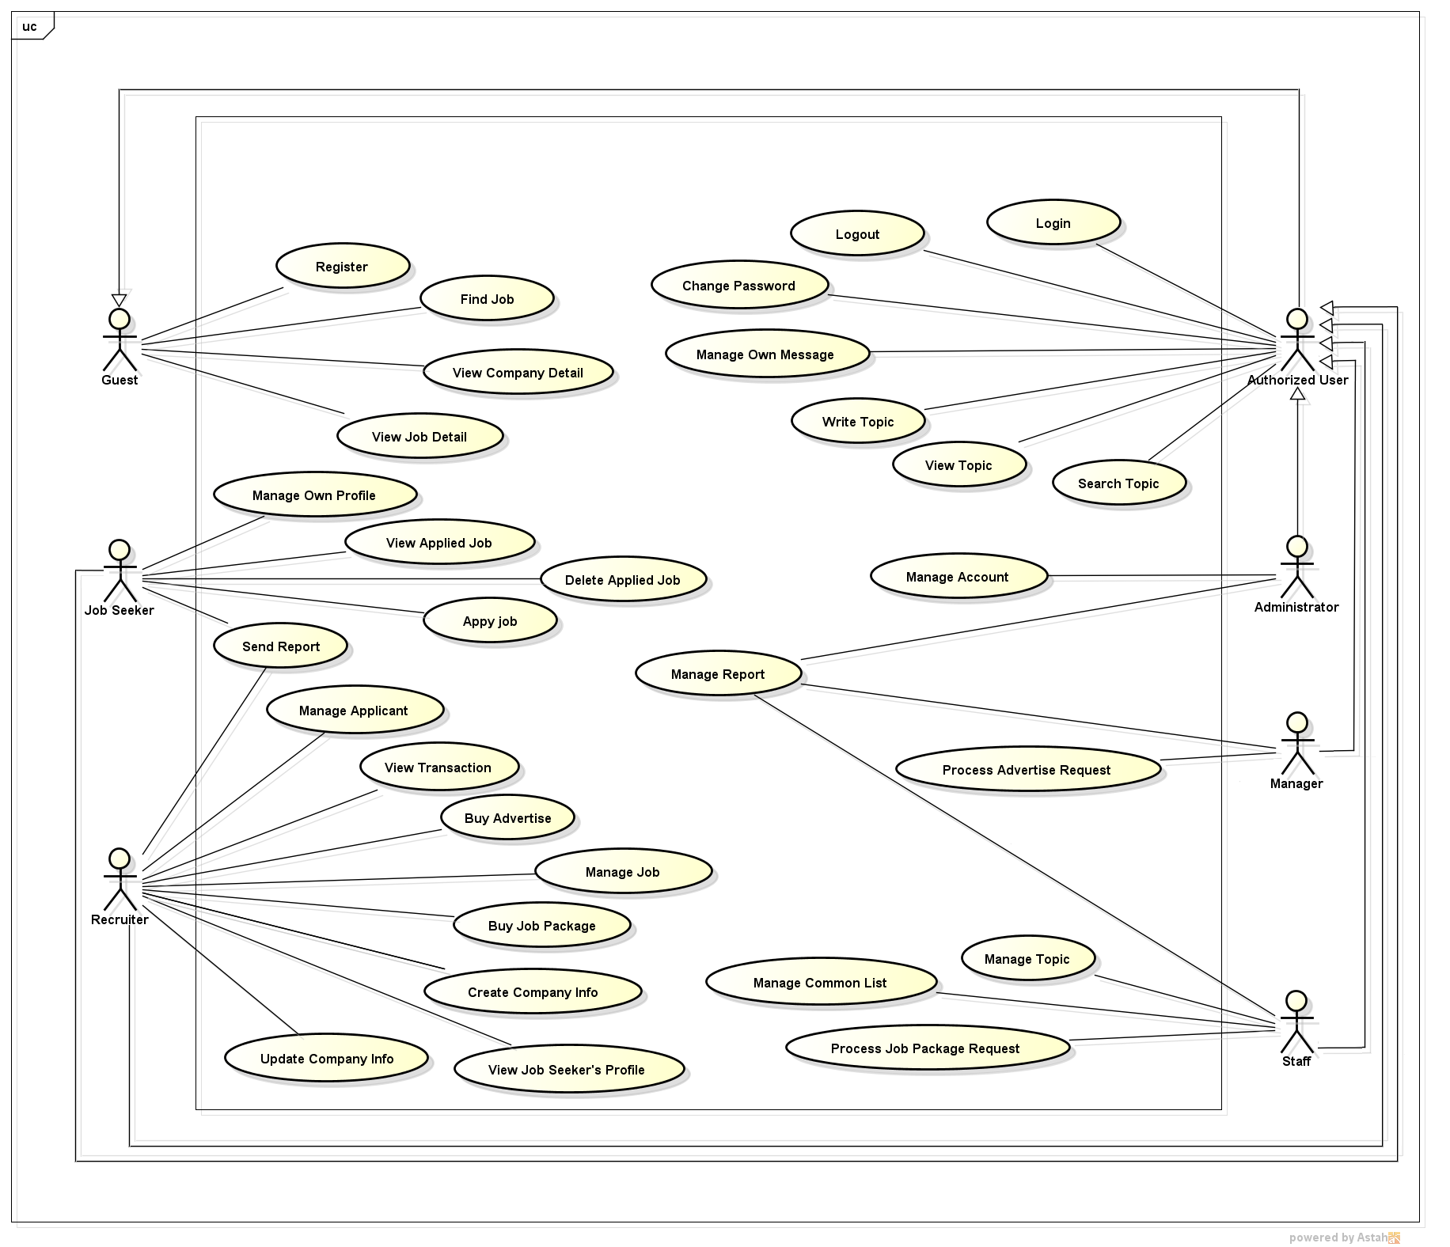

Figure 1: Use Case Overview

#### <Guest> Overview Use case

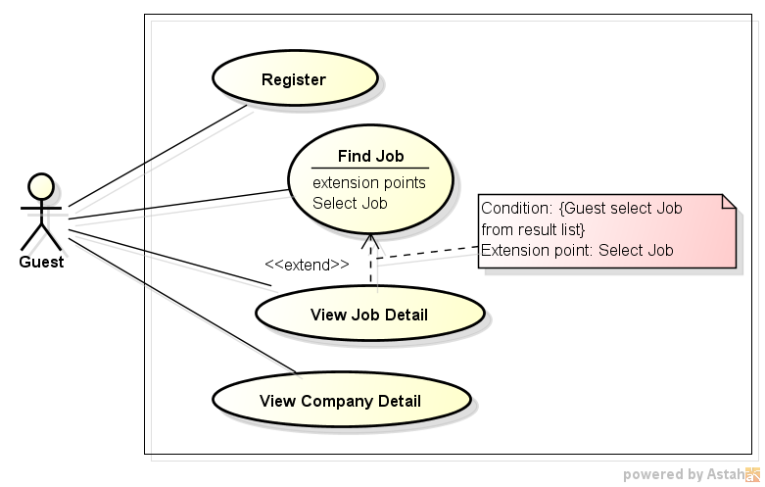

Figure 2: Guest - Use Case Overview

##### Register

###### Use case diagram

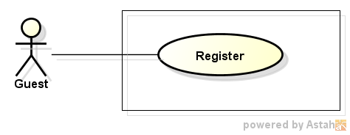

Figure 3: Guest - Register

###### Use case description

|  |  |  |  |
| --- | --- | --- | --- |
| **USE CASE –001** | | | |
| **Use Case No.** | 001 | **Use Case Version** | 1.0 |
| **Use Case Name** | Register | | |
| **Author** | Vo Hoan Thien | | |
| **Date** | 18/05/2015 | **Priority** | Normal |
| **Actor:** Guest  **Summary:**   * In order to use more functions on the website, Guest have to register for an account which can log into the website with jobseeker role or recruiter role.   **Goal:**   * Authorize users and guarantee security of the website.   **Triggers:**   * Guest click on “Đăng kí” button.   **Preconditions:**   * “Đăng kí” button is displayed and activating on navigation bar.   **Post Conditions:**   * Successful:   + New account is created and added into database.   + Successful message is displayed to user.   + User can login * Failed:   + Nothing is added to database.   + Error message is displayed to user.   **Main Success Scenario:**   |  |  |  | | --- | --- | --- | | Step | Actor Action | System Response | | 1 | User click on “Đăng kí” button on the navigation bar. | Sign up form is displayed. | | 2 | - User chooses option to become jobseeker or recruiter.  - User input data to all required filed in the sign up form. | All input data is displayed correctly on the form with no validation error message. | | 3 | User click on “Đăng kí” button on the form. | Successful message: “Tài khoản tạo thành công” is displayed. | | 4 | User click on “Đồng ý” button. | Successful message is closed.  Login form is displayed. |   **Alternative Scenario:**   |  |  |  | | --- | --- | --- | | No. | Actor Action | System Response | | 1 | User uses any function that require login (apply job, create topic). | Message require user to sign up is displayed. | | User click on “Đồng ý” button. | Sign up form is displayed and activating. | | 2 | After step 1, user clicks on “Hủy” button. | - Sign up form is closed.  - Current page is activated. |   **Exceptions:**   |  |  |  | | --- | --- | --- | | No. | Actor Action | System Response | | 1 | At step 2, user input nothing into “Tên đăng nhập” field. | Validation message: “Tên đăng nhập không được bỏ trống” is displayed. | | 2 | At step 2, user input nothing into “Mật khẩu” field. | Validation message: “Mật khẩu không được bỏ trống” is displayed. | | 3 | - At step 2, user input nothing some characters into “Mật khẩu” field.  - Left blank “Xác nhận mật khẩu filed” or input a difference string. | Validation message: “Mật khẩu lặp lại không trùng lặp” is displayed. | | 4 | At step 2, user input nothing into “Địa chỉ email” field. | Validation message: “Vui lòng nhập địa chỉ e-mail” is displayed. | | 5 | At step 2, user input an email that has been used to register before. | Validation message: “Địa chỉ email đã được sử dụng”. |   **Relationships:**  N/A  **Business Rules:**   * Each email address can only be used for one time to registry. | | | |

##### Find Job

###### Use case diagram

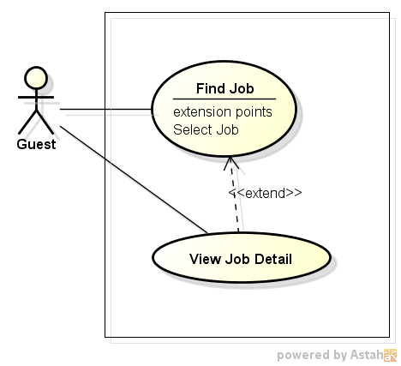

Figure 4: Guest - Find Job

###### Use case description

|  |  |  |  |
| --- | --- | --- | --- |
| **USE CASE –002** | | | |
| **Use Case No.** | 002 | **Use Case Version** | 1.0 |
| **Use Case Name** | Find Jobs | | |
| **Author** | Nguyen Ngoc Thien | | |
| **Date** | 18/05/2015 | **Priority** | High |
| **Actor:** for all roles in the system.  **Summary:**   * User can make a quick search to find out information about jobs they concern by its name, by minimum salary, work location, etc. right after entering to website.   **Goal:**   * Search for jobs directly from home page.   **Triggers:**   * Job Searching System homepage screen is displayed.   **Preconditions:**   * Job Searching System homepage screen is displayed, the job name, minimum salary are entered and criteria such as expected work location, job categories are selected. Search button is clicked.   **Post Conditions:**   * Job Searching System displays a list of job.   **Main Success Scenario:**   |  |  |  | | --- | --- | --- | | Step | Actor Action | System Response | | 1 | Type job’s name, minimum salary into textbox, select school level, select expected work location select job category on Job Searching System homepage. | Auto-complete feature will check and gives suggested list bases on characters that user input. | | 2 | Click “Tìm kiếm” button. | * Searching in database all of jobs that satisfy search key word and criteria. * Display a list of jobs that suitable with those criteria or show message “Không có công việc nào thỏa tiêu chí của bạn”. |   **Alternative Scenario:**  N/A  **Exceptions:**  N/A  **Relationships:**   * Extension point of: View Job Detail.   **Business Rules:**  Only display jobs matching with search condition and have end date larger than current date. | | | |

##### View Job Detail

###### Use case diagram



Figure 5: Guest - View Job Detail

###### Use case description

|  |  |  |  |
| --- | --- | --- | --- |
| **USE CASE –003** | | | |
| **Use Case No.** | 003 | **Use Case Version** | 1.0 |
| **Use Case Name** | View Job Detail | | |
| **Author** | Nguyen Ngoc Thien | | |
| **Date** | 18/05/2015 | **Priority** | High |
| **Actor:** for all roles in the system.  **Summary:**   * When user clicks a job link, redirect to job’s information page.   **Goal:**   * Display detailed information of clicked job.   **Triggers:**   * Click job post link on homepage or search result page.   **Preconditions:**   * Job Searching System homepage screen is displayed and has at least one job or on the job searching result page has at least one job.   **Post Conditions:**   * Job Information page is displayed.   **Main Success Scenario:**   |  |  |  | | --- | --- | --- | | Step | Actor Action | System Response | | 1 | Click on a job in home page or on job searching result page. | Redirect to “Thông tin công việc” page contains:   * Job’s basic information block contains: * Job’s name * Company’s logo * Company’s info * Company’s location * Salary * “Nộp đơn” button * Job summary block contains: * Job level * Job category * Foreign language * Job’s benefit block contains: * A list of benefit * Job’s skill contains: * Essential skills are required for job. * Job’s description block contains: * Description what this job is about and what job seeker will must do. * Job requirement block contains: * Specific requirements for job such as experiment, attitude, etc. |   **Alternative Scenario:**  N/A  **Exceptions:**   |  |  |  | | --- | --- | --- | | No | Actor Action | System Response | | 1 | Click on job in home page or on job searching result page which was deleted in database. | Show error message “ Công việc này không tồn tại”. | | 2 | Click on job in home page or on job searching result page which end date larger than now. | Show error message “ Công việc này đã hết hạn hiển thị”. |   **Relationships:**  N/A  **Business Rules:**  Users cannot see job if end date of job is larger than the time which user click job. | | | |

##### View Company Detail

###### Use case diagram

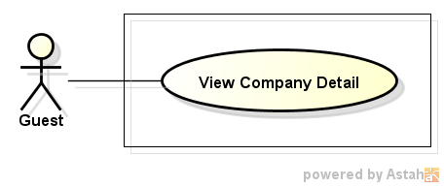

Figure 6: View Company Detail

###### Use case description

|  |  |  |  |
| --- | --- | --- | --- |
| **USE CASE –004** | | | |
| **Use Case No.** | 004 | **Use Case Version** | 1.0 |
| **Use Case Name** | View Company Detail | | |
| **Author** | Nguyen Ngoc Thien | | |
| **Date** | 18/05/2015 | **Priority** | High |
| **Actor:** for all roles in the system.  **Summary:**   * This use case allows user to view profile of a company.   **Goal:**   * Allow user view detail information of a company.   **Triggers:**   * Click on a company name link.   **Preconditions:**   * Have at least a company on Job Searching System.   **Post Conditions:**   * Company profile page is displayed successfully.   **Main Success Scenario:**   |  |  |  | | --- | --- | --- | | Step | Actor Action | System Response | | 1 | Select a company name link on Job Searching System. | Redirect to “Thông tin công ty” page. |   **Alternative Scenario:**  N/A  **Exceptions:**  N/A  **Relationships:**  N/A  **Business Rules:**  N/A | | | |

#### <Authorized User> Overview Use case

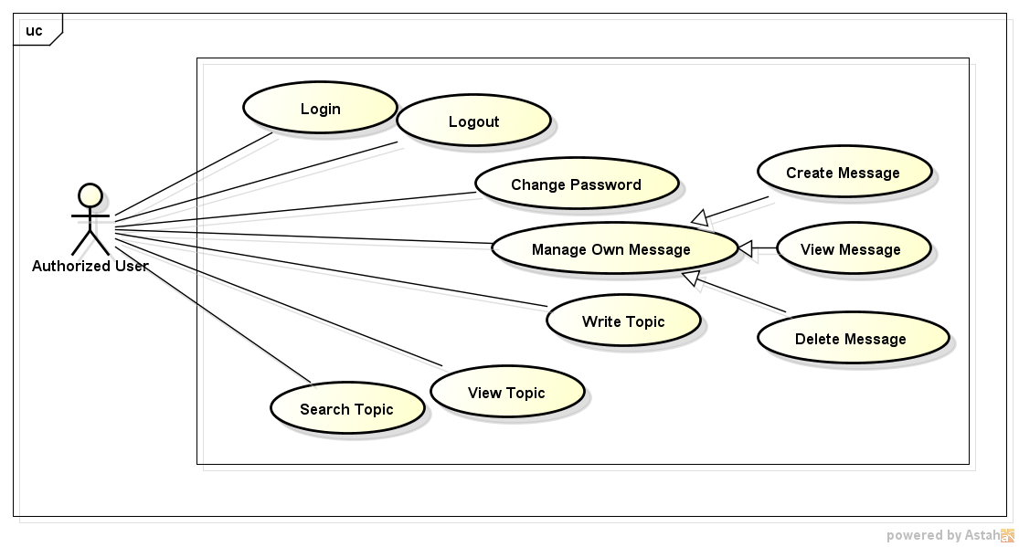

Figure 7: Authorized User - Over View

##### Login

###### Use case diagram

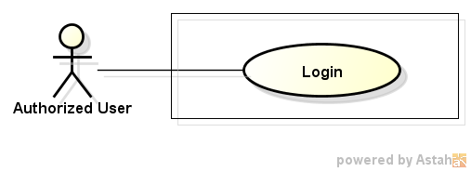

Figure 8: Authorized User - Login

###### Use case description

|  |  |  |  |
| --- | --- | --- | --- |
| **USE CASE –005** | | | |
| **Use Case No.** | 005 | **Use Case Version** | 1.0 |
| **Use Case Name** | Login | | |
| **Author** | Nguyen Ngoc Thien | | |
| **Date** | 18/05/2015 | **Priority** | High |
| **Actor:** Job seeker, Recruiter, Manager, Administrator  **Summary:**   * This use case allows user to log into the Job Searching System.   **Goal:**   * Log into the Job Searching System with specific role to do functions of that role.   **Triggers:**   * Click “Đăng nhập” link on top right of page.   **Preconditions:**   * Job Searching System is displayed successfully.   **Post Conditions:**   * Login to Job Searching System successfully.   **Main Success Scenario:**   |  |  |  | | --- | --- | --- | | Step | Actor Action | System Response | | 1 | Click “Đăng nhập” link on top right of page. | Redirect to “Đăng nhập” page contains:   * “Email” textbox * “Mật khẩu” textbox * “Đăng nhập” button * “Quên mật khẩu” link * “Đăng ký ngay ” button | | 2 | Fill email and password to field “Email” and “Mật khẩu” then click “Đăng nhập” button. | Login to Job Searching System save session for that user and redirect to homepage. |   **Alternative Scenario:**   |  |  |  | | --- | --- | --- | | No | Actor Action | System Response | | 1 | Click “Quên mật khẩu” link. | Redirect to “Quên mật khẩu” page contains:   * “Email của bạn” textbox. * “Reset mật khẩu”button. | | 2 | Fill email and click “Reset mật khẩu” button. | * System sends an email contains a link to reset password for that account message. * Display message “Hệ thống đã gửi 1 email giúp bạn reset mật khẩu. Vui lòng kiểm tra hộp thư của bạn”. | | 3 | Click “Đăng ký ngay” button. | Redirect to “Đăng ký tài khoản người tìm việc” page |   **Exceptions:**   |  |  |  | | --- | --- | --- | | No | Actor Action | System Response | | 1 | Fill unregistered email to “Email” field and click “Đăng nhập ” button. | Display error message “Email này chưa được đắng ký với hệ thống”. | | 2 | Fill a registered email but wrong password to “Mật khẩu” field and click “Đăng ký”. | Display error message “Sai mật khẩu”. |   **Relationships:**  N/A  **Business Rules:**   * If user login failed for 5 times consecutive, system will not allow that user login in next 30 minutes. | | | |

##### Logout

###### Use case diagram

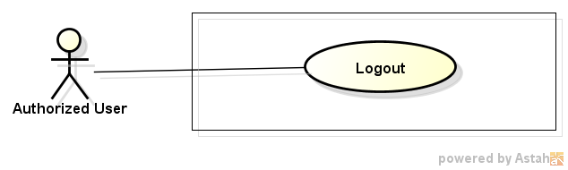

Figure 9: Authorized User - Logout

###### Use case description

|  |  |  |  |
| --- | --- | --- | --- |
| **USE CASE –006** | | | |
| **Use Case No.** | 006 | **Use Case Version** | 1.0 |
| **Use Case Name** | Logout | | |
| **Author** | Nguyen Ngoc Thien | | |
| **Date** | 18/05/2015 | **Priority** | High |
| **Actor:** Job seeker, Recruiter, Manager, Administrator  **Summary:**   * This use case allows user to logout of the Job Searching System.   **Goal:**   * Logout of the Job Searching System.   **Triggers:**   * Click “Đăng xuất” item in drop down menu of user.   **Preconditions:**   * Job Searching System is displayed successfully.   **Post Conditions:**   * Logout of Job Searching System successfully.   **Main Success Scenario:**   |  |  |  | | --- | --- | --- | | Step | Actor Action | System Response | | 1 | Click “Đăng xuất” item on drop down menu of user. | * Delete session of that user. * Redirect to home page. |   **Alternative Scenario:**  N/A  **Exceptions:**  N/A  **Relationships:**  N/A  **Business Rules:**  N/A | | | |

##### Change Password

###### Use case diagram

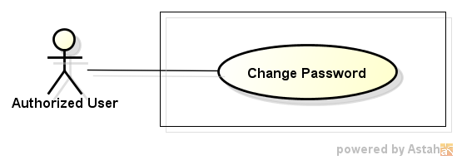

Figure 10: Authorized User - Change Password

###### Use case description

|  |  |  |  |
| --- | --- | --- | --- |
| **USE CASE –007** | | | |
| **Use Case No.** | 007 | **Use Case Version** | 1.0 |
| **Use Case Name** | Change Password | | |
| **Author** | Nguyen Ngoc Thien | | |
| **Date** | 18/05/2015 | **Priority** | High |
| **Actor:** Job Seeker, Manager, Administrator  **Summary:**   * This use case allows user to change password.   **Goal:**   * Allow user update their current password.   **Triggers:**   * Click drop down menu beside username text on top right of page, then select “Tài khoản” item.   **Preconditions:**   * User login successfully.   **Post Conditions:**   * Password is updated.   **Main Success Scenario:**   |  |  |  | | --- | --- | --- | | Step | Actor Action | System Response | | 1 | Select “Tài khoản” item from user’s drop down menu. | Redirect to “Thông tin cá nhân” page contain:   * **“Thông tin cá nhân” block** * “Họ” textbox, required. maxlength:16 characters * “Tên” textbox, required, max length: 16 characters. * “Địa chỉ email” textbox, required, max length: 50 characters. * “Mật khẩu” textbox, required, min length: 6 characters, max length: 16 characters. * “Mật khẩu phải từ 6 đến 16 kí tự bao gồm ít nhất 1 chữ hoa, 1 chữ thường và 1 số” text. * “Xác nhận mật khẩu”: textbox, required. * “Giới tính”: radio button with 2 option “Nam” and “Nữ”. * “Quốc tịch”: combo-box contains 152 nations. * “Ngày sinh”: calendar textbox. * “Lưu” button. * **“Đổi mật khẩu” block** * “Mật khẩu hiện tại”: textbox, required. * “Mật khẩu mới”: textbox, min length: 6 characters, max length: 16 characters. * “Mật khẩu phải từ 6 đến 16 kí tự bao gồm ít nhất 1 chữ hoa, 1 chữ thường và 1 số”: text. * “Xác nhận mật khẩu mới”: textbox, required. * “Lưu” button * “**Đổi email truy cập” block** * “Email hiện tại”: text, display current email. * “Xác nhận mật khẩu”: text box, required. * “Nhập email truy cập mới”: textbox, required, max length: 50 characters. * “Xác nhận email mới”: textbox, required. * “Lưu”: button. | | 2 | Fill current password to “Mật khẩu hiện tại” textbox, new password to “Mật khẩu mới” textbox and confirm password to “Xác nhận mật khẩu mới” textbox then click button “Lưu”. | -Find user’s account in database that match with current user’s account.  - Update new password for that user’s account. |   **Alternative Scenario:**  N/A  **Exceptions:**   |  |  |  | | --- | --- | --- | | No | Actor Action | System Response | | 1 | User leave empty on mandatory fields then click “Lưu” button. | Show error message “Vui lòng nhập thông tin cần thiết” beside mandatory fields. | | 2 | In “Đổi mật khẩu” block, input a wrong password for field “Mật khẩu hiện tại” then click “Lưu” button. | Show error message “Mật khẩu hiện tại không đúng” besides “Mật khẩu hiện tại” textbox. | | 3 | Input confirm password is not as password which is entered in ”Mật khẩu” textboxto “Xác nhận mật khẩu mới” textbox and move cursor out of field. | Auto show error message “Mật khẩu xác nhận phải giống mât khẩu đã nhập”. | | 4 | Input password to “Mật khẩu” field is not strong enough and move cursor out of field. | Show error message “Mật khẩu phải có ít nhất 1 ký tự hoa, 1 ký tự thường và 1 số”. |   **Relationships:**   * Login   **Business Rules:**   * When update password user must input correctly their current password. * Password must have at least an uppercase, a lower case and a number. | | | |

##### Create Message

###### Use case diagram

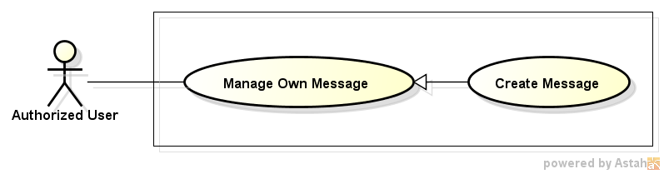

Figure 11: Authorized User - Create Message

###### Use case description

|  |  |  |  |
| --- | --- | --- | --- |
| **USE CASE –008** | | | |
| **Use Case No.** | 008 | **Use Case Version** | 1.0 |
| **Use Case Name** | Create message | | |
| **Author** | Nguyen Ngoc Thien | | |
| **Date** | 18/05/2015 | **Priority** | High |
| **Actor:** Job Seeker, Recruiter, Manager, Administrator  **Summary:**   * This use case allows user create message and send to others.   **Goal:**   * Send messages   **Triggers:**   * Click “Tin nhắn” item in drop down menu of user. * Then click “Tạo tin nhắn” button.   **Preconditions:**   * Login successfully.   **Post Conditions:**   * Send successfully a message to other.   **Main Success Scenario:**   |  |  |  | | --- | --- | --- | | Step | Actor Action | System Response | | 1 | Click “Tin nhắn” item on drop down menu of job seeker. | Redirect to “Tin nhắn” page contains below items:   * List of message with checkbox in every item * “Tạo tin nhắn” button. * “Xóa tin nhắn” button | | 2 | Click “Tạo tin nhắn” button. | Display a dialog contains:   * “Người nhận” textbox, required * “Nội dung” text area, required, maxlength: 1000 * “Gửi” button * “Hủy” button | | 3 | Input receiver’s name on “Người nhận” textbox. | Auto suggest name of users contain characters of user input. | | 4 | Input content on “Nội dung” text area and click button “Gửi”. | Send message to receivers. |   **Alternative Scenario:**   |  |  |  | | --- | --- | --- | | No | Actor Action | System Response | | 1 | At step 3, click “Hủy” button instead of “Gửi” button. | Dismiss dialog. |   **Exceptions:**   |  |  |  | | --- | --- | --- | | No | Actor Action | System Response | | 1 | Leave empty on “Người nhận” text box. | When leave focus out of textbox auto show error message “Vui lòng điền người nhận” beside “Người nhận” text box. | | 2 | Leave empty on “Nội dung” text area. | When leave focus out of textbox auto show error message “Vui lòng nhập nội dung” on bottom of “Nội dung” text area. |   **Relationships:**   * Login   **Business Rules:**   * User can send message for many users including themselves. | | | |

##### View Message

###### Use case diagram

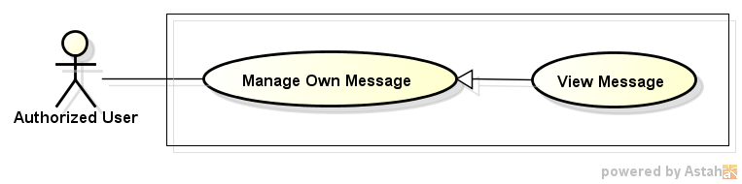

Figure 12: Authorized User - View Message

###### Use case description

|  |  |  |  |
| --- | --- | --- | --- |
| **USE CASE –009** | | | |
| **Use Case No.** | 009 | **Use Case Version** | 1.0 |
| **Use Case Name** | View message | | |
| **Author** | Nguyen Ngoc Thien | | |
| **Date** | 18/05/2015 | **Priority** | High |
| **Actor:** Job Seeker, Recruiter, Manager, Administrator  **Summary:**   * This use case allows user see messages are sent from others.   **Goal:**   * View messages   **Triggers:**   * Click “Tin nhắn” item in drop down menu of user.   **Preconditions:**   * Login successfully   **Post Conditions:**   * Display a list of message or “Empty” message.   **Main Success Scenario:**   |  |  |  | | --- | --- | --- | | Step | Actor Action | System Response | | 1 | Click “Tin nhắn” item on drop down menu of job seeker. | Redirect to “Tin nhắn” page contains below items:   * List of message with checkbox in every item * “Tạo tin nhắn” button. * “Xóa tin nhắn” button | | 2 | Click on specific message want to read. | Redirect to Message Content page display content of message. |   **Alternative Scenario:**  N/A  **Exceptions:**  N/A  **Relationships:**   * Login   **Business Rules:**  N/A | | | |

##### Delete Message

###### Use case diagram

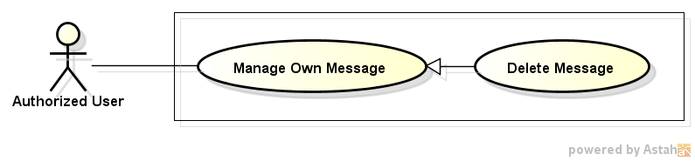

Figure 13: Authorized User - Delete Message

###### Use case description

|  |  |  |  |
| --- | --- | --- | --- |
| **USE CASE –010** | | | |
| **Use Case No.** | 010 | **Use Case Version** | 1.0 |
| **Use Case Name** | Delete message | | |
| **Author** | Nguyen Ngoc Thien | | |
| **Date** | 18/05/2015 | **Priority** | High |
| **Actor:** Job Seeker, Recruiter, Manager, Administrator  **Summary:**   * This use case allows user delete messages.   **Goal:**   * Delete messages.   **Triggers:**   * Click “Tin nhắn” item in drop down menu of user. * Tick on checkbox on message which want to delete then click “Xóa tin nhắn” button.   **Preconditions:**   * Login successfully.   **Post Conditions:**   * Delete successfully messages.   **Main Success Scenario:**   |  |  |  | | --- | --- | --- | | Step | Actor Action | System Response | | 1 | Click “Tin nhắn” item on drop down menu of job seeker. | Redirect to “Tin nhắn” page contains below items:   * List of message with checkbox in every item * “Tạo tin nhắn”button. * “Xóa tin nhắn” button | | 2 | Tick on checkboxes which want to delete, then click button “Xóa tin nhắn”. | Display a delete confirm dialog contains:   * “Bạn có muốn xóa những tin nhắn này?” text * “Có” button * “Không” button | | 3 | Click “Có” button. | Delete those messages in database and refresh list of message. |   **Alternative Scenario:**   |  |  |  | | --- | --- | --- | | No | Actor Action | System Response | | 1 | At step 3, click “Hủy” button instead of “Gửi” button. | Dismiss dialog. |   **Exceptions:**   |  |  |  | | --- | --- | --- | | 1 | Delete a message that already is deleted. | Display a dialog “Tin nhắn này đã được xóa”. |   **Relationships:**   * Login   **Business Rules:**  N/A | | | |

##### Write Topic

###### Use case diagram

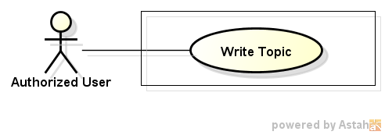

Figure 14: Authorized User - Write Topic

###### Use case description

|  |  |  |  |
| --- | --- | --- | --- |
| **USE CASE –011** | | | |
| **Use Case No.** | 011 | **Use Case Version** | 1.0 |
| **Use Case Name** | Write Topic | | |
| **Author** | Pham Quoc Thai | | |
| **Date** | 20/05/2015 | **Priority** | High |
| **Actor:** Job Seeker, Recruiter, Manager, Administrator  **Summary:**   * In this case, after logging, manager can create new topic.   **Goal:**   * Create new topic.   **Triggers:**   * Click button "Tạo chủ đề mới" on Topic List page.   **Preconditions:**   * Manager must login into website.   **Post Conditions:**  N/A  **Main Success Scenario:**   |  |  |  | | --- | --- | --- | | Step | Actor Action | System Response | | 1 | Click button "Tạo chủ đề mới " on Topic List page. | Show Create New Topic page. | | 2 | Enter content after that click Button “Create”. | New topic added into database. |   **Alternative Scenario:**  N/A  **Exceptions:**  N/A  **Relationships:**  N/A  **Business Rules:**  N/A | | | |

##### View Topic

###### Use case diagram

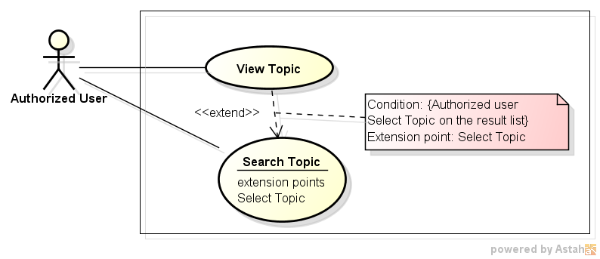

Figure 15: View Topic

###### Use case description

|  |  |  |  |
| --- | --- | --- | --- |
| **USE CASE –012** | | | |
| **Use Case No.** | 012 | **Use Case Version** | 1.0 |
| **Use Case Name** | View topic | | |
| **Author** | Pham Quoc Thai | | |
| **Date** | 20/05/2015 | **Priority** | High |
| **Actor:** Job Seeker, Recruiter, Manager, Administrator  **Summary:**   * In this case, manager can view topic list.   **Goal:**   * All topic display successfully.   **Triggers:**   * Click on tab "Danh sách chủ đề" on manager home page.   **Preconditions:**   * Manager must login into website.   **Post Conditions:**  N/A  **Main Success Scenario:**   |  |  |  | | --- | --- | --- | | Step | Actor Action | System Response | | 1 | Click on tab "Danh sách chủ đề" on manager home page. | All topic display successfully. |   **Alternative Scenario:**  N/A  **Exceptions:**  N/A  **Relationships:**  N/A  **Business Rules:**  N/A | | | |

##### Search Topic

###### Use case diagram

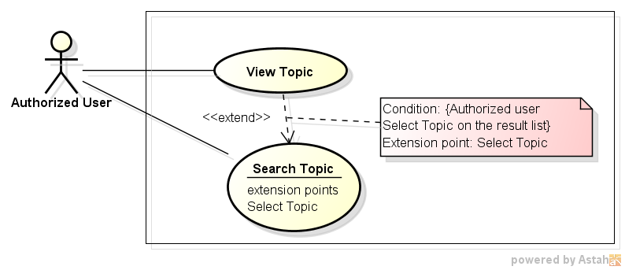

Figure 16: Search Topic

###### Use case description

|  |  |  |  |
| --- | --- | --- | --- |
| **USE CASE –013** | | | |
| **Use Case No.** | 013 | **Use Case Version** | 1.0 |
| **Use Case Name** | Search Topic | | |
| **Author** | Vo Hoan Thien | | |
| **Date** | 18/05/2015 | **Priority** | Normal |
| **Actor:** Jobseeker, Recruiter, Manager, Staff, Administrator  **Summary:**   * Allow user to post topic about sharing experiment, guideline, website regulation, …   **Goal:**   * Provide a communication place for user.   **Triggers:**   * Authorized user enters key word into text box and click on “Tìm kiếm” button.   **Preconditions:**   * User login successfully into website. * Topic List Page, Pending List Page, Own List Page is displayed and activating. * List of topic is displayed with one or more result.   **Post Conditions:**   * Show the topics which have their title contain key word. * If no matching result, show the inform message to user.   **Main Success Scenario:**   |  |  |  | | --- | --- | --- | | Step | Actor Action | System Response | | 1 | User inputs keyword into text box, then click on “Tìm kiếm” button. | - Data table is refreshed.  - Topics which their title contain the key word is displayed on the table. |   **Alternative Scenario:**   |  |  |  | | --- | --- | --- | | No. | Actor Action | System Response | | 1 | User inputs keyword that is not existed on any topic title. | - The table is not displayed.  - Message: “Không có bài viết nào tương tự được tìm thấy” is displayed. |   **Exceptions:**  N/A  **Relationships:**  N/A  **Business Rules:**   * This search function only looking for the topics with the title contain the entered key words. | | | |

#### <Jobseeker> Overview Use case

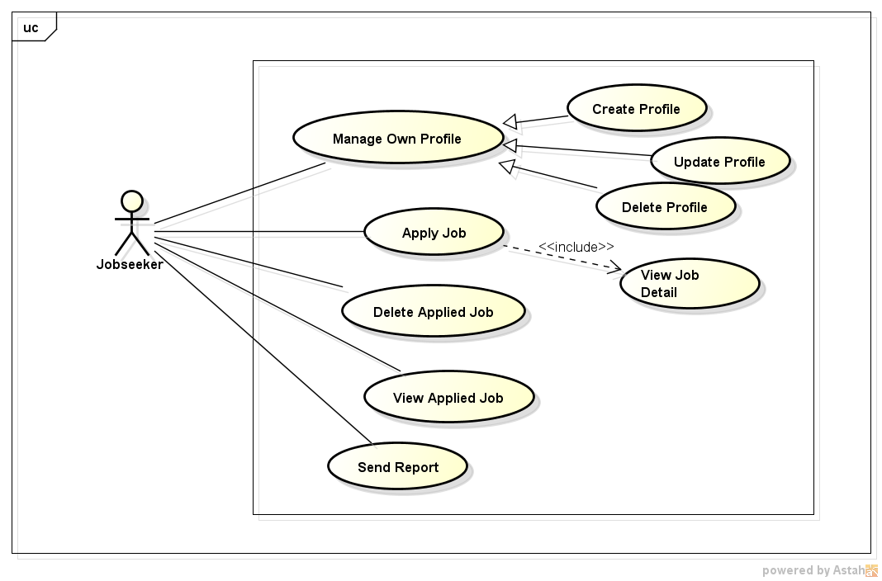

Figure 17: Jobseeker - Overview Use Case

##### Create Profile

###### Use case diagram

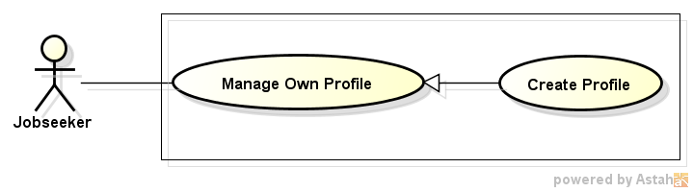

Figure 18: Create Profile

###### Use case description

|  |  |  |  |
| --- | --- | --- | --- |
| **USE CASE –014** | | | |
| **Use Case No.** | 014 | **Use Case Version** | 1.0 |
| **Use Case Name** | Create Profile | | |
| **Author** | Nguyen Ngoc Thien | | |
| **Date** | 18/05/2015 | **Priority** | High |
| **Actor:**   * Job Seeker   **Summary:**   * This use case allow user to create a resume which recruiter will see when job seeker apply any job.   **Goal:**   * Create job seeker ‘s resume   **Triggers:**   * Click drop down menu beside username text on top right of page, then select “Tạo hồ sơ” item   **Preconditions:**   * User login successfully with role Job Seeker   **Post Conditions:**   * A resume is created and send to Manager for censorship   **Main Success Scenario:**   |  |  |  | | --- | --- | --- | | Step | Actor Action | System Response | | 1 | Select “Tạo hồ sơ” item from user’s drop down menu | Redirect to “Tạo hồ sơ” page contains:  **- “Thông tin cá nhân” block:**   * “Ngày sinh” textbox that display a calendar when focus, date format: dd/mm/yyyy, required * “Tình trạng hôn nhân” radio button with 2 option “Married” and “Single” * “Địa chỉ” textbox, min length:0. Max length:50 * “Quốc gia” combo box, contains 152 nations, required * “Giới tính” radio button with 2 option “Male” and “Female”, required * “Thành phố/Tỉnh” combo box, contains all city and province of selected country, required * “Điện thoại di động” textbox, min length:8 max length:16, required   **- “Summary” block :**   * “Kinh nghiệm” textbox with “Mới tốt nghiệp chưa có kinh nghiệm” checkbox beside, only number allowed, min length:1, max length: 3, required.   If checkbox is checked, textbox will be disabled, required   * “Bằng cấp cao nhất” combo box, contains item below: * Trung học * Trung cấp * Cao đẳng * Cử nhân * Kỹ sư * Kế toán viên công chứng * Thạc sĩ * Thạc sĩ quản trị kinh doanh * Tiến sĩ luật * Tiến sĩ * Dược sĩ * Dược sĩ y khoa * Khác * “Ngoại ngữ” combo box contains all language with “Add more” button, when user click add more, system will insert a more combo box for “Language” field, required * “Trình độ” combo box with 4 items below: * Sơ cấp * Trung cấp * Cao cấp * Bản ngữ * “Công ty gần đây nhất ” textbox, minlength:0 , max length:50 * “Vị trí gần đây nhất” textbox, min length:0, max length:50 * “Vị trí mong muốn” textbox, min length: 0, max length:50, required * “Nơi làm việc mong muốn” textbox, minlength:0, max length:50, required * “Mức lương mong muốn radio button with 2 options “Thỏa thuận” and “USD/tháng” with textbox beside, required. If user choose “USD/month” radio button textbox can be inputted otherwise it is disable ,   - **“Hồ sơ/Mục tiêu nghề nghiệp” block:**   * “Giới thiệu bản thân và mô tả mục tiêu nghề nghiệp của bạn” text area, min length:10, max length: 5000, required   **- “Kinh nghiệm làm việc” block:**   * “Vị trí” textbox, min length:3, max length:50, required * “Công ty” textbox, min length:3, max length:50, required * “Từ tháng” textbox that display a calendar when focus * “Đếm tháng” textbox that display a calendar when focus * “Mô tả” text area, min length: 10 , max length: 5000   **- “Học vấn và bằng cấp” block:**   * “Chuyên nghành” textbox, min length:5, max length: 50, required * “Trường” textbox, min length:5, max length: 50, required * “Bằng cấp” combo box , required ,will contains item below: * Trung học * Trung cấp * Cao đẳng * Cử nhân * Kỹ sư * Kế toán viên công chứng * Thạc sĩ * Thạc sĩ quản trị kinh doanh * Tiến sĩ luật * Tiến sĩ * Dược sĩ * Dược sĩ y khoa * Khác * “Thành tựu” text area, min length:10, max length:5000   **- “**Tạo**”** button, “Hủy” button | | 2 | Enter information to field and click “Tạo” button | - A new resume for that job’s seeker is inserted to database  - Send job seeker’s resume to Manager for censorship  - Redirect to “Quản lý hồ sơ” page |   **Alternative Scenario:**   |  |  |  | | --- | --- | --- | | No | Actor Action | System Response | | 1 | At step 2, user click “Hủy” button instead of “Tạo” button | Redirect to Job Searching System homepage |   **Exceptions:**   |  |  |  | | --- | --- | --- | | No | Actor Action | System Response | | 1 | User leave empty on mandatory fields then click “Tạo” button | Show error message “Vui lòng nhập thông tin cần thiết” beside mandatory fields | | 2 | Input information to “Địa chỉ” field with length out of valid range | Show error message “Độ dài tối đa không được vượt quá 50 kí tự” | | 3 | Input information to “Cell number” field with length out of valid range | Show error message “Độ dài tối thiều là 6 và độ dài tối đá không được vượt quá 16 kí tự” | | 4 | Input year to “Kinh nghiệm” field with length out of valid range | Show error message “Độ dài tối thiều là 1 và độ dài tối đá không được vượt quá 3 kí tự” | | 5 | Input information to “Vị trí gần đây nhất” field with length out of valid range | Show error message “Độ dài tối đa không được vượt quá 50 kí tự” | | 6 | Input information to “Vị trí mong muốn” field with length out of valid range | Show error message “Độ dài tối đa không được vượt quá 50 kí tự” | | 7 | Input information to “Nơi làm việc” field with length out of valid range | Show error message “Độ dài tối đa không được vượt quá 50 kí tự” | | 8 | Input information to “Giới thiệu bản thân và mô tả mục tiêu nghề nghiệp của bạn” field with length out of valid range | Show error message “Độ dài tối thiều là 10 và độ dài tối đá không được vượt quá 1000 kí tự” | | 9 | Input information to “Vị trí” field with length out of valid range | Show error message “Độ dài tối thiều là 3 và độ dài tối đá không được vượt quá 50 kí tự” | | 10 | Input information to “Công ty” field with length out of valid range | Show error message “Độ dài tối thiều là 3 và độ dài tối đá không được vượt quá 50 kí tự” | | 11 | Input information to “Mô tả” field with length out of valid range | Show error message “Độ dài tối thiều là 10 và độ dài tối đá không được vượt quá 1000 kí tự” | | 12 | Input information to “Chuyên nghành” field with length out of valid range | Show error message “Độ dài tối thiều là 5 và độ dài tối đá không được vượt quá 50 kí tự” | | 12 | Input information to “Trường học” field with length out of valid range | Show error message “Length must be in range from 5 to 50” | | 13 | Input information to “Thành tựu” field with length out of valid range | Show error message “Độ dài tối thiều là 10 và độ dài tối đá không được vượt quá 5000 kí tự” |   **Relationships:**   * Login   **Business Rules:**   * Job seeker’s resume must be censored before public for recruiter view and using for job suggestion | | | |

##### Update Profile

###### Use case diagram

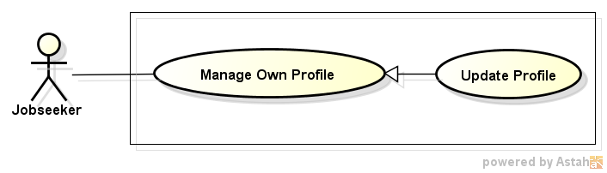

Figure 19: Update Profile

###### Use case description

|  |  |  |  |
| --- | --- | --- | --- |
| **USE CASE –015** | | | |
| **Use Case No.** | 015 | **Use Case Version** | 1.0 |
| **Use Case Name** | Update Profile | | |
| **Author** | Nguyen Ngoc Thien | | |
| **Date** | 18/05/2015 | **Priority** | High |
| **Actor:**   * Job Seeker   **Summary:**   * This use case allow user to edit resume   **Goal:**   * Update information on job’s seeker resume   **Triggers:**   * Click dropdown menu of user then select “Quản lý hồ sơ” item * In “Quản lý hồ sơ” page will display a list of resume , job seeker click “Sửa” link on same line with resume that want to edit   **Preconditions:**   * User login successfully with role Job Seeker * “Quản lý hồ sơ” page display successfully   **Post Conditions:**   * Resume is Updated and send to Manager for censorship   **Main Success Scenario:**   |  |  |  | | --- | --- | --- | | Step | Actor Action | System Response | | 1 | Select “Quản lý hồ sơ” item from user’s drop down menu | Redirect to “Quản lý hồ sơ” page contains: | | 2 | Select “Sửa” link with same line with resume that want to edit | Redirect to “Cập nhật hồ sơ” page contains:  **- “Thông tin cá nhân” block:**   * “Ngày sinh” textbox that display a calendar when focus, date format: dd/mm/yyyy, required * “Tình trạng hôn nhân” radio button with 2 option “Married” and “Single” * “Địa chỉ” textbox, min length:0. Max length:50 * “Quốc gia” combo box, contains 152 nations, required * “Giới tính” radio button with 2 option “Male” and “Female”, required * “Thành phố/Tỉnh” combo box, contains all city and province of selected country, required * “Điện thoại di động” textbox, min length:8 max length:16, required   **- “Summary” block :**   * “Kinh nghiệm” textbox with “Mới tốt nghiệp chưa có kinh nghiệm” checkbox beside, only number allowed, min length:1, max length: 3, required.   If checkbox is checked, textbox will be disabled, required   * “Bằng cấp cao nhất” combo box, contains item below: * Trung học * Trung cấp * Cao đẳng * Cử nhân * Kỹ sư * Kế toán viên công chứng * Thạc sĩ * Thạc sĩ quản trị kinh doanh * Tiến sĩ luật * Tiến sĩ * Dược sĩ * Dược sĩ y khoa * Khác * “Ngoại ngữ” combo box contains all language with “Add more” button, when user click add more, system will insert a more combo box for “Language” field, required * “Trình độ” combo box with 4 items below: * Sơ cấp * Trung cấp * Cao cấp * Bản ngữ * “Công ty gần đây nhất ” textbox, minlength:0 , max length:50 * “Vị trí gần đây nhất” textbox, min length:0, max length:50 * “Vị trí mong muốn” textbox, min length: 0, max length:50, required * “Nơi làm việc mong muốn” textbox, minlength:0, max length:50, required * “Mức lương mong muốn radio button with 2 options “Thỏa thuận” and “USD/tháng” with textbox beside, required. If user choose “USD/month” radio button textbox can be inputted otherwise it is disable ,   - **“Hồ sơ/Mục tiêu nghề nghiệp” block:**   * “Giới thiệu bản thân và mô tả mục tiêu nghề nghiệp của bạn” text area, min length:10, max length: 5000, required   **- “Kinh nghiệm làm việc” block:**   * “Vị trí” textbox, min length:3, max length:50, required * “Công ty” textbox, min length:3, max length:50, required * “Từ tháng” textbox that display a calendar when focus * “Đếm tháng” textbox that display a calendar when focus * “Mô tả” text area, min length: 10 , max length: 5000   **- “Học vấn và bằng cấp” block:**   * “Chuyên nghành” textbox, min length:5, max length: 50, required * “Trường” textbox, min length:5, max length: 50, required * “Bằng cấp” combo box , required ,will contains item below: * Trung học * Trung cấp * Cao đẳng * Cử nhân * Kỹ sư * Kế toán viên công chứng * Thạc sĩ * Thạc sĩ quản trị kinh doanh * Tiến sĩ luật * Tiến sĩ * Dược sĩ * Dược sĩ y khoa * Khác * “Thành tựu” text area, min length:10, max length:5000   **- “**Lưu**”** button, “Hủy” button | | 3 | Enter information to field and click “Lưu” button | - Access to database and update field of resume  - Send job seeker’s updated resume to Manager for censorship  - Redirect to “Quản lý hồ sơ” page |   **Alternative Scenario:**   |  |  |  | | --- | --- | --- | | No | Actor Action | System Response | | 1 | At step 2, user click “Hủy” button instead of “Lưu” button | Redirect to “Quản lý hồ sơ” page |   **Exceptions:**   |  |  |  | | --- | --- | --- | | No | Actor Action | System Response | | 1 | User leave empty on mandatory fields then click “Lưu” button | Show error message “Vui lòng nhập thông tin cần thiết” beside mandatory fields | | 2 | Input information to “Địa chỉ” field with length out of valid range | Show error message “Độ dài tối đa không được vượt quá 50 kí tự” | | 3 | Input information to “Cell number” field with length out of valid range | Show error message “Độ dài tối thiều là 6 và độ dài tối đá không được vượt quá 16 kí tự” | | 4 | Input year to “Kinh nghiệm” field with length out of valid range | Show error message “Độ dài tối thiều là 1 và độ dài tối đá không được vượt quá 3 kí tự” | | 5 | Input information to “Vị trí gần đây nhất” field with length out of valid range | Show error message “Độ dài tối đa không được vượt quá 50 kí tự” | | 6 | Input information to “Vị trí mong muốn” field with length out of valid range | Show error message “Độ dài tối đa không được vượt quá 50 kí tự” | | 7 | Input information to “Nơi làm việc” field with length out of valid range | Show error message “Độ dài tối đa không được vượt quá 50 kí tự” | | 8 | Input information to “Giới thiệu bản thân và mô tả mục tiêu nghề nghiệp của bạn” field with length out of valid range | Show error message “Độ dài tối thiều là 10 và độ dài tối đá không được vượt quá 1000 kí tự” | | 9 | Input information to “Vị trí” field with length out of valid range | Show error message “Độ dài tối thiều là 3 và độ dài tối đá không được vượt quá 50 kí tự” | | 10 | Input information to “Công ty” field with length out of valid range | Show error message “Độ dài tối thiều là 3 và độ dài tối đá không được vượt quá 50 kí tự” | | 11 | Input information to “Mô tả” field with length out of valid range | Show error message “Độ dài tối thiều là 10 và độ dài tối đá không được vượt quá 1000 kí tự” | | 12 | Input information to “Chuyên nghành” field with length out of valid range | Show error message “Độ dài tối thiều là 5 và độ dài tối đá không được vượt quá 50 kí tự” | | 12 | Input information to “Trường học” field with length out of valid range | Show error message “Độ dài tối thiều là 5 và độ dài tối đá không được vượt quá 50 kí tự” | | 13 | Input information to “Thành tựu” field with length out of valid range | Show error message “Độ dài tối thiều là 10 và độ dài tối đá không được vượt quá 5000 kí tự” |   **Relationships:**   * Login   **Business Rules:**   * Job seeker’s resume after updating must be censored before public for recruiter view and using for job suggestion | | | |

##### Delete Profile

###### Use case diagram

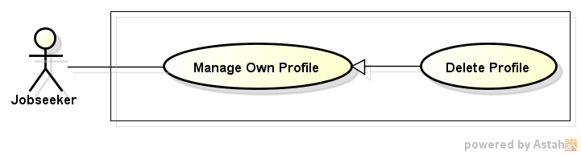

Figure 20: Delete Profile

###### Use case description

|  |  |  |  |
| --- | --- | --- | --- |
| **USE CASE –016** | | | |
| **Use Case No.** | 016 | **Use Case Version** | 1.0 |
| **Use Case Name** | Delete Resume | | |
| **Author** | Nguyen Ngoc Thien | | |
| **Date** | 18/05/2015 | **Priority** | High |
| **Actor:**   * Job Seeker   **Summary:**   * This use case allow user to delete resume   **Goal:**   * Delete a resume of job seeker   **Triggers:**   * Click dropdown menu of user then select “Quản lý hồ sơ” item * In “Quản lý hồ sơ” page will display a list of resume , job seeker click “Xóa” link on same line with resume that want to delete   **Preconditions:**   * User login successfully with role Job Seeker * “Quản lý hồ sơ” page display successfully   **Post Conditions:**   * Selected resume is deleted   **Main Success Scenario:**   |  |  |  | | --- | --- | --- | | Step | Actor Action | System Response | | 1 | Select “Quản lý hồ sơ” item from user’s drop down menu | Redirect to “Quản lý hồ sơ” page contains: | | 2 | Select “Xóa” link with same line with resume that want to edit | - Display delete confirm dialog with content ”Bạn có chắc muốn xóa hồ sơ này” and 2 button “Có” and “Không” | | 3 | Select “Có” button | - Searching in database resume id and jobseeker id that match with selected resume and job seeker  - Delete resume, dismiss dialog and auto-update resume list without refresh page |   **Alternative Scenario:**   |  |  |  | | --- | --- | --- | | No | Actor Action | System Response | | 1 | At step 3, user click “No” button instead of “Save” button | Redirect to “Quản lý hồ sơ” page |   **Exceptions:**  **N/A**  **Relationships:**   * Login   **Business Rules:**  **N/A** | | | |

##### Apply Job

###### Use case diagram

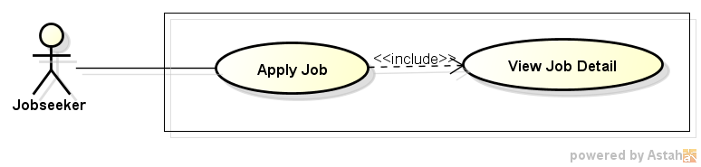

Figure 21: Apply Job

###### Use case description

|  |  |  |  |
| --- | --- | --- | --- |
| **USE CASE –017** | | | |
| **Use Case No.** | 017 | **Use Case Version** | 1.0 |
| **Use Case Name** | Apply Job | | |
| **Author** | Nguyen Ngoc Thien | | |
| **Date** | 18/05/2015 | **Priority** | High |
| **Actor:**   * Job Seeker   **Summary:**   * This use case allow user to apply a job on Job Searching System   **Goal:**   * Allow job seeker send apply request to recruiter   **Triggers:**   * Click on a job post * In a job post click “Nộp đơn” button, “Nộp đơn” dialog is displayed * Then in “Nộp đơn” dialog click button “Gửi”   **Preconditions:**   * User login successfully with role Job Seeker * Have at least a job post on Job Searching System * Redirect successfully to a job post’s information page   **Post Conditions:**   * Apply request of job seeker is sent to recruiter   **Main Success Scenario:**   |  |  |  | | --- | --- | --- | | Step | Actor Action | System Response | | 1 | Select a job post in Job Searching System | Redirect to “Thông tin công việc” page | | 2 | Click “Nộp đơn” | Display a “Nộp đơn ”dialog contains:   * Overview information of jobseeker like: avatar, name, email, location, phone number * “Hồ sơ” radio button with options allow user choose Resumes which they created on Job Searching System * “Gửi” button * “Hủy” button | | 3 | Select “Gửi” button | - Sending apply job request to recruiter which contains informations in “Nộp đơn” dialog   * Display send applied request success dialog   - Dismiss “Nộp đơn” dialog |   **Alternative Scenario:**   |  |  |  | | --- | --- | --- | | No | Actor Action | System Response | | 1 | At step 3 click “Hủy” button instead of “Gửi” button | Dismiss “Nộp đơn” dialog |   **Exceptions:**  **N/A**  **Relationships:**   * Login * View job   **Business Rules:**   * A jobseeker cannot send many apply request for a job * Jobseeker cannot apply a job if they don’t have any resume | | | |

##### Delete Applied Job

###### Use case diagram

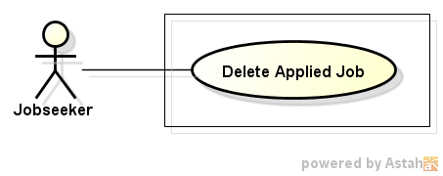

Figure 22: Delete Applied Job

###### Use case description

|  |  |  |  |
| --- | --- | --- | --- |
| **USE CASE –018** | | | |
| **Use Case No.** | 018 | **Use Case Version** | 1.0 |
| **Use Case Name** | Delete Applied Job | | |
| **Author** | Nguyen Ngoc Thien | | |
| **Date** | 18/05/2015 | **Priority** | High |
| **Actor:**   * Job Seeker   **Summary:**   * This use case allow user to cancel a job request which is sent to recruiter   **Goal:**   * Delete a job request   **Triggers:**   * From drop down menu of jobseeker click on “Quản lý tình trạng ứng tuyển” item * Click “Xóa” link on same line with job that you want to cancel apply request   **Preconditions:**   * Job seeker have at least a job request   **Post Conditions:**   * Cancel a apply request to recruiter   **Main Success Scenario:**   |  |  |  | | --- | --- | --- | | Step | Actor Action | System Response | | 1 | Click “Quản lý tình trạng ứng tuyển” item on drop down menu of jobseeker | Redirect to “Quản lý tình trạng ứng tuyển” page contains a list of apply job requests | | 2 | Click “Xóa” link on same line with apply job request which want to delete | Delete applied job request in database and send message to inform about canceling applied job request of job seeker to recruiter |   **Alternative Scenario:**  N/A  **Exceptions:**  N/A  **Relationships:**   * Login   **Business Rules:**  N/A | | | |

##### View Applied Job

###### Use case diagram

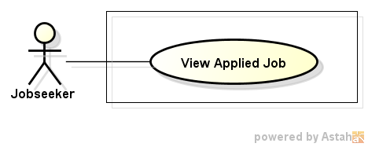

Figure 23: View Applied Job

###### Use case description

|  |  |  |  |
| --- | --- | --- | --- |
| **USE CASE –019** | | | |
| **Use Case No.** | 019 | **Use Case Version** | 1.0 |
| **Use Case Name** | View Applied Job | | |
| **Author** | Nguyen Ngoc Thien | | |
| **Date** | 18/05/2015 | **Priority** | High |
| **Actor:**   * Job Seeker   **Summary:**   * This use case allow user to view applied job request   **Goal:**   * View applied job requests   **Triggers:**   * Click “Công việc cuả tôi” item in drop down menu of job seeker   **Preconditions:**   * Login successfully with role Job seeker   **Post Conditions:**   * Display a list of applied job request or “Bạn hiện tại không ứng tuyển vào bất kì công việc nào” message   **Main Success Scenario:**   |  |  |  | | --- | --- | --- | | Step | Actor Action | System Response | | 1 | Click “Công việc của tôi” item on drop down menu of job seeker | Redirect to “Công việc của tôi” page contains a list of applied job request |   **Alternative Scenario:**  **N/A**  **Exceptions:**  **N/A**  **Relationships:**   * Login   **Business Rules:**  **N/A** | | | |

##### Send Report

###### Use case diagram

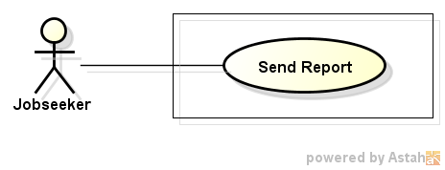

Figure 24: Send Report

###### Use case description

|  |  |  |  |
| --- | --- | --- | --- |
| **USE CASE –020** | | | |
| **Use Case No.** | 020 | **Use Case Version** | 1.0 |
| **Use Case Name** | Send Report | | |
| **Author** | Nguyen Ngoc Thien | | |
| **Date** | 18/05/2015 | **Priority** | High |
| **Actor:** Jobseeker, Recruiter  **Summary:**   * In this case, user can create problem reports to send to staff   **Goal:**   * User can create problem reports to send to Admin   **Triggers:**   * Click “Báo cáo” button on Job Detail page or on Topic Detail page   **Preconditions:**   * Recruiter and Jobseeker have already logged in   **Post Conditions:**   * Send report success to Admin   **Main Success Scenario:**   |  |  |  | | --- | --- | --- | | Step | Actor Action | System Response | | 1 | Click on “Báo cáo” button | Report modal is displayed contains:   * Text area, max length:1000 * “Gửi” button and “Hủy” button | | 2 | Input content in text area and click “Gửi” button | Send report to Admin and display success dialog “ Bạn đã gửi báo cáo thành công” | | 3 | Click “Đóng” button | Dismiss report modal |   **Alternative Scenario:**   |  |  |  | | --- | --- | --- | | Step | Actor Action | System Response | | 1 | Recruiter click on “Hủy” button | Dismiss report modal |   **Exceptions:**   |  |  |  | | --- | --- | --- | | Step | Actor Action | System Response | | 1 | Don’t enter report’s content to text area and click “Gửi” button | Display a alert “Vui lòng nhập nội dung báo cáo” | | 2 | Enter to text area more than 1000 characters and click “Gửi” button | Display error message “Nội dung báo cáo không được vượt quá 1000 ký tự” |   **Relationships:**   * Login use case   **Business Rules:**  N/A | | | |

#### <Recruiter> Overview Use case

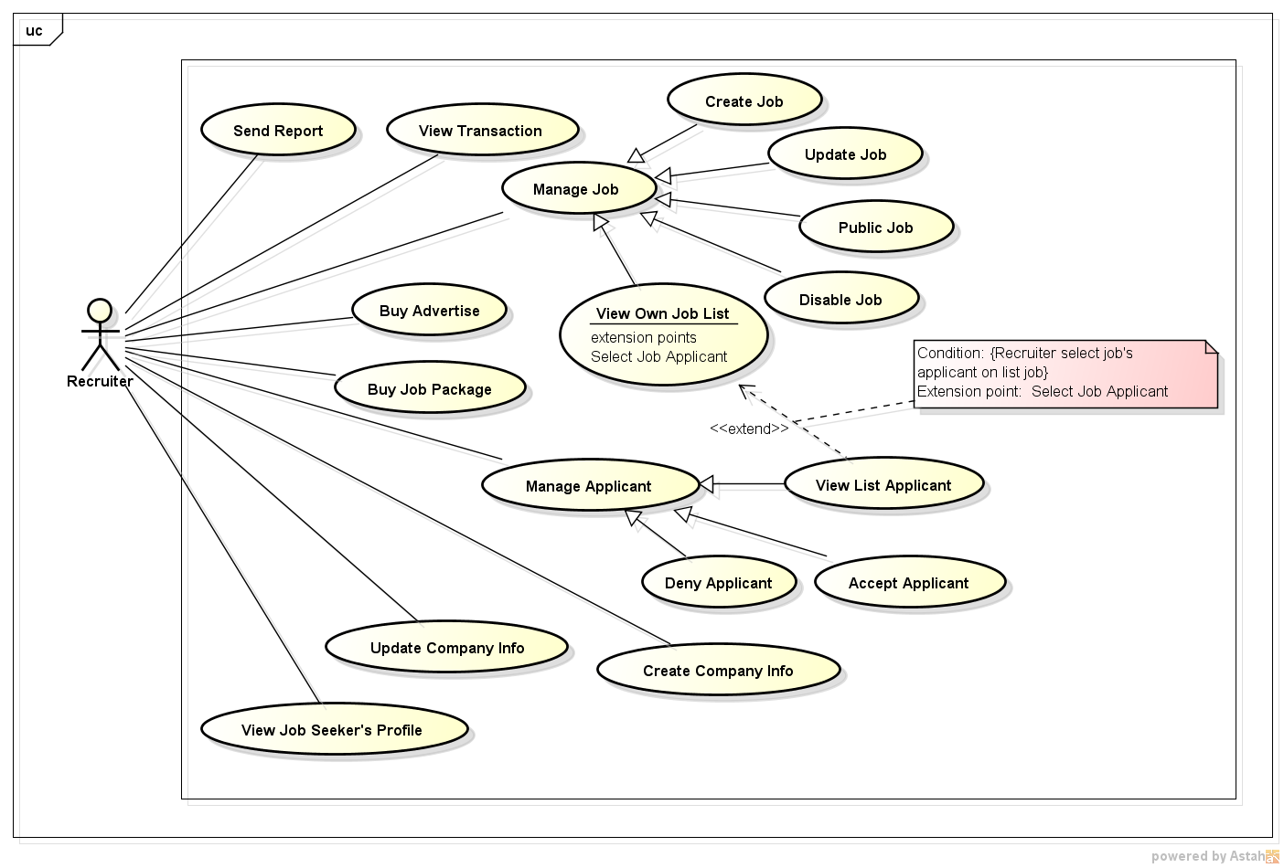

Figure 25: Recruiter - Overview Use Case

##### Send Report

This function has been specified before. (Reference UC-020, Jobseeker – Send Report 3.2.2.3.7)

##### View Transaction

###### Use case diagram

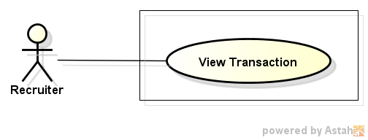

Figure 26: View Transaction

###### Use case description

|  |  |  |  |
| --- | --- | --- | --- |
| **USE CASE –021** | | | |
| **Use Case No.** | 021 | **Use Case Version** | 1.0 |
| **Use Case Name** | View Transaction | | |
| **Author** | Tran Chung Thanh | | |
| **Date** | 18/05/2015 | **Priority** | High |
| **Actor:** Recruiter  **Summary:**  In this case, recruiters can view all online transactions  **Goal:**  Recruiter can view online transactions successfully  **Triggers:**  Recruiter click on “Xem Thông tin các giao dịch” tab in recruiters home page  **Preconditions:**  Recruiter has already logged in  **Post Conditions:**  N/A  **Main Success Scenario:**   |  |  |  | | --- | --- | --- | | Step | Actor Action | System Response | | 1 | Recruiter click on “Xem Thông tin các giao dịch” tab in recruiters home page | Online transactions page will be displayed |   **Alternative Scenario:**  N/A  **Exceptions:**  N/A  **Relationships:**  Log in use case  **Business Rules:**   * Online transactions show immediately | | | |

##### Create Job

###### Use case diagram

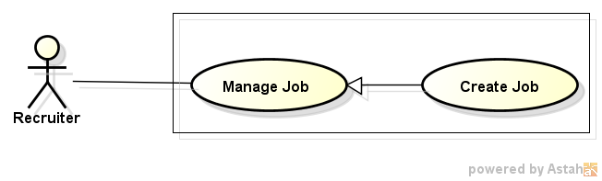

Figure 27: Create Job

###### Use case description

|  |  |  |  |
| --- | --- | --- | --- |
| **USE CASE –022** | | | |
| **Use Case No.** | 022 | **Use Case Version** | 1.0 |
| **Use Case Name** | Create Job | | |
| **Author** | Vo Hoan Thien | | |
| **Date** | 18/05/2015 | **Priority** | Normal |
| **Actor:** Recruiter  **Summary:**   * Recruiter can create job to recruit applicant.   **Goal:**   * Allow recruiter to create job.   **Triggers:**   * Recruiter clicks on login avatar on navigation bar and select “Tạo việc làm” item.   **Preconditions:**   * User login to website successfully with role recruiter. * Job package is still available for posting at least one job. * Navigation bar is displayed and activating.   **Post Conditions:**   * Successful:   + New job is created and added into database.   + Successful message is displayed to user.   + User can find created job in Job Own List Page. * Failed:   + Nothing is added to database.   + Error message is displayed to user.   **Main Success Scenario:**   |  |  |  | | --- | --- | --- | | Step | Actor Action | System Response | | 1 | User clicks on login avatar on navigation bar and select “Tạo việc làm” item. | Create job from is displayed. | | 2 | User inputs valid data to all required field in the job create form. | All input data is displayed correctly on the form with no validation error message. | | 3 | User click on “Đăng kí” button on the form. | Successful message: “Tạo công việc thành công” is displayed. | | 4 | User click on “Đồng ý” button. | - Successful message is closed.  - Job Own List Page is displayed. |   **Alternative Scenario:**   |  |  |  | | --- | --- | --- | | No. | Actor Action | System Response | | 1 | On Job Own List Page, user clicks on “Tạo việc làm mới” button. | Create job from is displayed. | | 2 | At step 3, user clicks on “Hủy” button. | Redirect user to index page. |   **Exceptions:**   |  |  |  | | --- | --- | --- | | No. | Actor Action | System Response | | 1 | User input invalid data or not input n any required filed in the job create form. | Validation message is displayed for any error right next to the input data field. |   **Relationships:**  N/A  **Business Rules:**   * Job is created with public status equal “false”. | | | |

##### Update Job

###### Use case diagram

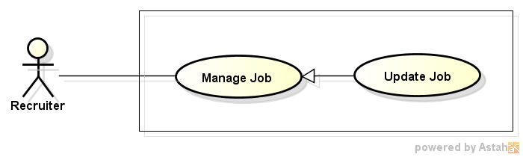

Figure 28: Update Job

###### Use case description

|  |  |  |  |
| --- | --- | --- | --- |
| **USE CASE – 023** | | | |
| **Use Case No.** | 023 | **Use Case Version** | 1.0 |
| **Use Case Name** | Update Job | | |
| **Author** | Tran Chung Thanh | | |
| **Date** | 18/05/2015 | **Priority** | High |
| **Actor:**  Recruiter  **Summary:**  In this case, recruiters can manage job posting  **Goal:**  Recruiter can view job posting successfully  **Triggers:**  Recruiter click on “Quản Lý Công Việc” tab in recruiters home page, then click on “Cập Nhật” button beside any job posted in manage job page  **Preconditions:**  Recruiter has already logged in  **Post Conditions:**  Redirect user to the job’s info page  **Main Success Scenario:**   |  |  |  | | --- | --- | --- | | Step | Actor Action | System Response | | 1 | Recruiter click on “Quản Lý Công Việc” button in recruiters home page | Manage job page will be displayed | | 2 | Recruiter choice click on “Cập Nhật ” button beside any job posted | Recruiter can refill or update info of the job | | Recruiter fill all info of the job |  | | Recruiter click on “Lưu” button | Show message : “Bạn Đã Cập Nhật Thông Tin Công Việc Thành Công” | | Recruiter click on “OK” button | Redirect recruiter to the Job’s info page |   **Alternative Scenario:**   |  |  |  | | --- | --- | --- | | Step | Actor Action | System Response | | 1 | Recruiter click on “Quản Lý Công Việc” button in recruiters home page | Manage job page will be displayed | | 3 | Recruiter choice click on “Cập Nhật” button beside any job posted | Recruiter can refill or update info of the job | | Recruiter refill all info of the job |  | | Recruiter click on “Hủy” button | Redirect recruiter to the Job’s info page |   **Exceptions:**   |  |  |  | | --- | --- | --- | | Step | Actor Action | System Response | | 1 | Recruiter click on “Quản Lý Công Việc” button in recruiters home page | Manage job page will be displayed | | 2 | Recruiter choice click on “Cập Nhật” button beside any job posted | Recruiter can refill or update info of the job | | Recruiter fill some info of the job, but skipped some mandatory info |  | | Recruiter click on “Lưu” button | Show all required message for all missing mandatory info | | Recruiter click on “OK” button or close messages | Redirect recruiter to the Job’s info page |   **Relationships:**  Log in use case  **Business Rules:**   * Some mandatory data fields must required * Update the job within 3 seconds * Recruiter have to create a job before update the job | | | |

##### Public Job

###### Use case diagram

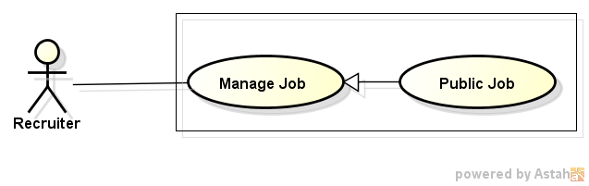

Figure 29: Public Job

###### Use case description

|  |  |  |  |
| --- | --- | --- | --- |
| **USE CASE –024** | | | |
| **Use Case No.** | 024 | **Use Case Version** | 1.0 |
| **Use Case Name** | Public Job | | |
| **Author** | Vo Hoan Thien | | |
| **Date** | 18/05/2015 | **Priority** | Normal |
| **Actor:** Recruiter  **Summary:**   * After create a job, recruiter must change its public status in order to allow user to view their job posting.   **Goal:**   * Allow recruiter to review the job before public them.   **Triggers:**   * Recruiter clicks on “Đăng tuyển” button of a certain job.   **Preconditions:**   * User login successfully into website with role recruiter. * Job Own List Page is displayed and activating. * At least one job created by this user, has public status equal “false” and their ended date is later than the current time exist on datbase.   **Post Conditions:**   * Public status is updated in database. * Status of updated job is changed into “Đã đăng tuyển”.   **Main Success Scenario:**   |  |  |  | | --- | --- | --- | | Step | Actor Action | System Response | | 1 | From job own list, user clicks on “Đăng tuyển” button. | Confirm dialog “Bạn có chắc muốn đăng tuyển công việc này?” | | 2 | User click on “Đồng ý” button. | - The data table is refreshed.  - At the selected job row:  + Status is changed into “Đã đăng tuyển”.  + “Đăng tyển” button is disappeared.  + “Hủy đăng tuyển” button is displayed. |   **Alternative Scenario:**   |  |  |  | | --- | --- | --- | | No. | Actor Action | System Response | | 1 | After step 2, user clicks on “Hủy” button. | - Confirm dialog is close.  - Job Own List Page is reactivated. |   **Exceptions:**   |  |  |  | | --- | --- | --- | | No. | Actor Action | System Response | | 1 | At step 2, update topic is already deleted. | - Validation message: “Đã có lỗi xảy ra trong quá trình cập nhật thông tin, vui lòng thử lại sau” is displayed.  - Job Own List Page is refreshed. |   **Relationships:**  N/A  **Business Rules:**   * Public job could be brings into disable, and the same for disable topic. | | | |

##### Disable Job

###### Use case diagram

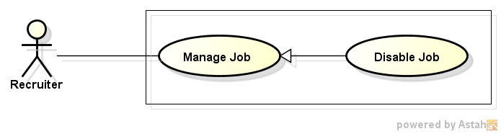

Figure 30: Disable Job

###### Use case description

|  |  |  |  |
| --- | --- | --- | --- |
| **USE CASE –025** | | | |
| **Use Case No.** | 025 | **Use Case Version** | 1.0 |
| **Use Case Name** | Public Job | | |
| **Author** | Vo Hoan Thien | | |
| **Date** | 18/05/2015 | **Priority** | Normal |
| **Actor:** Recruiter  **Summary:**   * Recruiter can change its public status in order to not allow user to view their job posting anymore.   **Goal:**   * Allow recruiter to bring their jobs offline in order to update them.   **Triggers:**   * Recruiter clicks on “Ẩn” button of a certain job.   **Preconditions:**   * User login successfully into website with role recruiter. * Job Own List Page is displayed and activating. * At least one job created by this user, has public status equal “true” and their ended date is later than the current time exist on database.   **Post Conditions:**   * Public status is updated in database. * Status of updated job is changed into “Không hiển thị”.   **Main Success Scenario:**   |  |  |  | | --- | --- | --- | | Step | Actor Action | System Response | | 1 | From job own list, user clicks on “Hủy đăng tuyển” button. | Confirm dialog “Bạn có chắc muốn ngừng việc đăng tuyển công việc này?” | | 2 | User click on “Đồng ý” button. | - The data table is refreshed.  - At the selected job row:  + Status is changed into “Không hiển thị”.  + “Hủy đăng tuyển” button is disappeared.  + “Đăng tuyển” button is displayed. |   **Alternative Scenario:**   |  |  |  | | --- | --- | --- | | No. | Actor Action | System Response | | 1 | After step 2, user clicks on “Hủy” button. | - Confirm dialog is close.  - Job Own List Page is reactivated. |   **Exceptions:**   |  |  |  | | --- | --- | --- | | No. | Actor Action | System Response | | 1 | At step 2, update topic is already deleted. | - Validation message: “Đã có lỗi xảy ra trong quá trình cập nhật thông tin, vui lòng thử lại sau” is displayed.  - Job Own List Page is refreshed. |   **Relationships:**  N/A  **Business Rules:**   * Public job could be brings into disable, and the same for disable topic. | | | |

##### View Own Job List

###### Use case diagram

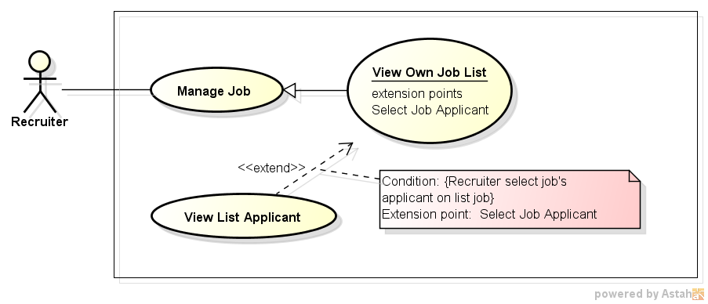

Figure 31: View Own Job List

###### Use case description

|  |  |  |  |
| --- | --- | --- | --- |
| **USE CASE –026** | | | |
| **Use Case No.** | 026 | **Use Case Version** | 1.0 |
| **Use Case Name** | View Own Job List | | |
| **Author** | Vo Hoan Thien | | |
| **Date** | 18/05/2015 | **Priority** | Normal |
| **Actor:** Recruiter  **Summary:**   * Recruiter can view their created jobs by this function.   **Goal:**   * Help recruiter on managing created jobs.   **Triggers:**   * Recruiter clicks on login avatar on navigation bar and choose “Quản lí công việc” item from dropdown menu.   **Preconditions:**   * User login successfully into website with role recruiter. * Navigation bar is displayed and activating. * At least one job created by this user is existed on database.   **Post Conditions:**   * Own Job List Page is displayed and activating.   **Main Success Scenario:**   |  |  |  | | --- | --- | --- | | Step | Actor Action | System Response | | 1 | User clicks on login avatar on navigation bar and choose “Quản lí công việc” item from dropdown menu. | - Own Job List is displayed and activating.  - All created jobs are displayed on data table. |   **Alternative Scenario:**   |  |  |  | | --- | --- | --- | | No. | Actor Action | System Response | | 1 | User creates a job successfully. | - Own Job List is displayed and activating.  - All created jobs are displayed on data table. | | 2 | At step 1, user has not created any job. | - Own Job List is displayed and activating.  - Message “Chưa có công việc nào được tạo”. |   **Exceptions:**  N/A  **Relationships:**  Extension point of View List Applicant  **Business Rules:**  N/A | | | |

##### Buy Advertise

###### Use case diagram

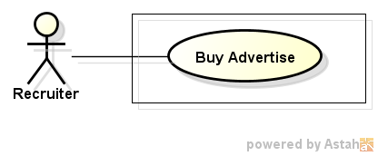

Figure 32: Buy Advertise

###### Use case description

|  |  |  |  |
| --- | --- | --- | --- |
| **USE CASE –027** | | | |
| **Use Case No.** | 027 | **Use Case Version** | 1.0 |
| **Use Case Name** | Buy Advertise Package | | |
| **Author** | Nguyen Ngoc Thien | | |
| **Date** | 18/05/2015 | **Priority** | High |
| **Actor:**   * Recruiter   **Summary:**   * In this case, recruiters can buy advertisepackage   **Goal:**   * Recruiter can buy advertise package   **Triggers:**   * Recruiter click on “Mua quảng cáo” item on drop down menu of recruiter   **Preconditions:**   * Recruiter has already logged in   **Post Conditions:**   * Send advertise package request to manager   **Main Success Scenario:**   |  |  |  | | --- | --- | --- | | Step | Actor Action | System Response | | 1 | Recruiter click on “Mua quảng cáo” item on drop down menu of recruiter | Redirect to Advertise Package page contains types of advertise package with “Mua” button in each type of package | | 2 | Recruiter click button “Mua” below any advertise package | Redirect to Invoice page contains:   * Web’s information blocks: * Name of web ( Job Searching System) * Phone * Address of office * Information of banking account * Logo upload block contains: * Image block * “Tải lên” button * Invoice information block contains: * Name of advertise package * Price * Position of advertise which will be displayed on website’s home page * “Gửi yêu cầu” button and “Hủy” button | | 3 | Recruiter click button “Tải lên” | Display a window browser dialog to choose logo image | | 4 | Choose image and click “Tải lên” button | Upload that image and load image into Image block | | 5 | Click “Gửi yêu cầu” button | Send Advertise Request Package to Staff and display dialog “Bạn đã gửi yêu cầu mua quảng cáo thành công” | | 6 | Click “Đóng” button on dialog | Redirect to Advertise Package page |   **Alternative Scenario:**   |  |  |  | | --- | --- | --- | | Step | Actor Action | System Response | | 1 | Click Hủy button | Redirect to Advertise Package page |   **Exceptions:**   |  |  |  | | --- | --- | --- | | Step | Actor Action | System Response | | 1 | Don’t upload logo and click “Gửi yêu cầu” button | Display warning dialog “Quý công ty vui lòng chọn logo sẽ được hiển thị trên trang web của chúng tôi” | | 2 | Select a not image file to upload | Display error dialog “Upload thất bại” | | 3 | Click “Gửi” button but connection to database is down | Display error dialog “Gửi yêu cầu mua gói coong việc thất bại ” |   **Relationships:**   * Login use case   **Business Rules:**   * Recruiter can buy many advertise package | | | |

##### Buy Job Package

###### Use case diagram

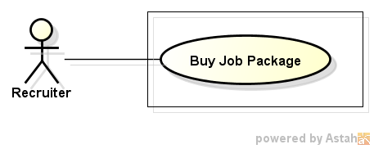

Figure 33: Buy Job Package

###### Use case description

|  |  |  |  |
| --- | --- | --- | --- |
| **USE CASE –028** | | | |
| **Use Case No.** | 028 | **Use Case Version** | 1.0 |
| **Use Case Name** | Buy Job Package | | |
| **Author** | Nguyen Ngoc Thien | | |
| **Date** | 18/05/2015 | **Priority** | High |
| **Actor:**   * Recruiter   **Summary:**   * In this case, recruiters can buy job package   **Goal:**   * Recruiter can buy job package   **Triggers:**   * Recruiter click on “Mua gói công việc” item on drop down menu of recruiter   **Preconditions:**   * Recruiter has already logged in   **Post Conditions:**   * Send job package request to manager   **Main Success Scenario:**   |  |  |  | | --- | --- | --- | | Step | Actor Action | System Response | | 1 | Recruiter click on “Mua gói công việc” item on drop down menu of recruiter | Redirect to Job Package page contains types of job package with “Mua” button in each type of package | | 2 | Recruiter click button “Mua” below any job package | Redirect to Invoice page contains:   * Web’s information blocks: * Name of web ( Job Searching System) * Phone * Address of office * Information of banking account * Invoice information block contains: * Name of job package * Price * Quantity of job package * “Gửi yêu cầu” button and “Hủy” button | | 3 | Click “Gửi yêu cầu” button | Send Job Package Request to Manager and display dialog “Bạn đã gửi yêu cầu mua gói công việc thành công” | | 4 | Click “Đóng” button on dialog | Redirect to Job Package page |   **Alternative Scenario:**   |  |  |  | | --- | --- | --- | | Step | Actor Action | System Response | | 1 | Click Hủy buttoc | Redirect to Job Package page |   **Exceptions:**   |  |  |  | | --- | --- | --- | | Step | Actor Action | System Response | | 1 | Click “Gửi” button but connection to database is down | Display error dialog “Gửi yêu cầu mua gói coong việc thất bại ” |   **Relationships:**   * Login use case   **Business Rules:**   * Recruiter can buy many job package | | | |

##### View List Applicant

###### Use case diagram

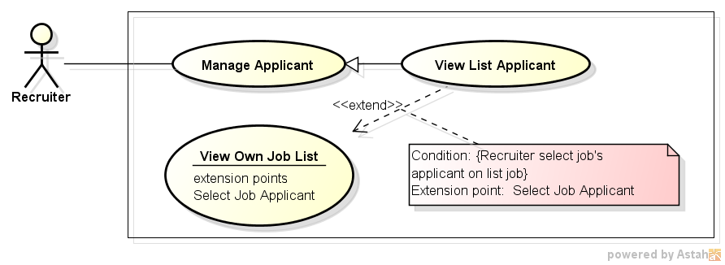

Figure 34: View List Applicant

###### Use case description

|  |  |  |  |
| --- | --- | --- | --- |
| **USE CASE –029** | | | |
| **Use Case No.** | 029 | **Use Case Version** | 1.0 |
| **Use Case Name** | View List Applicant | | |
| **Author** | Vo Hoan Thien | | |
| **Date** | 18/05/2015 | **Priority** | Normal |
| **Actor:** Recruiter  **Summary:**   * Recruiter can view list of applicants who have applied for their job.   **Goal:**   * Help recruiter on managing applicants.   **Triggers:**   * Recruiter clicks on “Quản lý ứng viên” button of a certain job.   **Preconditions:**   * User login successfully into website with role recruiter. * Job Own List Page is displayed and activating. * At least one job created by this user, which has ended date later than the current time, and number of applicant is more than 0. * Own Job List Page is displayed and activating.   **Post Conditions:**   * List Applicant Page is displayed and activating.   **Main Success Scenario:**   |  |  |  | | --- | --- | --- | | Step | Actor Action | System Response | | 1 | User clicks clicks on “Quản lý ứng viên” button of a certain job. | - List Applicant Page is displayed and activating.  - All applicants are displayed on data table. |   **Alternative Scenario:**   |  |  |  | | --- | --- | --- | | No. | Actor Action | System Response | | 1 | At step 1, the job has no applicant at all. | - “Quản lý ứng viên” button is not displayed. |   **Exceptions:**  N/A  **Relationships:**  Extension from View Own Job List.  **Business Rules:**   * If the selected job has no applicant, its “Quản lý ứng viên” button is not displayed. | | | |

##### Accept Applicant

###### Use case diagram

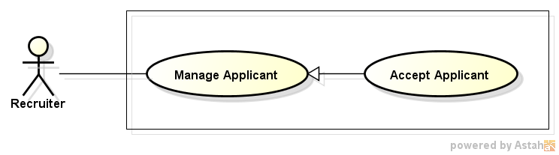

Figure 35: Accept Applicant

###### Use case description

|  |  |  |  |
| --- | --- | --- | --- |
| **USE CASE –030** | | | |
| **Use Case No.** | 030 | **Use Case Version** | 1.0 |
| **Use Case Name** | Accept Applicant | | |
| **Author** | Vo Hoan Thien | | |
| **Date** | 18/05/2015 | **Priority** | High |
| **Actor:** Recruiter  **Summary:**   * Recruiter can read applicant profile and mark them as accepted if that person is suitable for that job.   **Goal:**   * Help recruiter on manage their applicant.   **Triggers:**   * Staff clicks on “Chấp nhận” button.   **Preconditions:**   * User login successfully into website with role recruiter. * Applicant List Page is displayed and activating. * At least one applicant has status not equal “Đã chấp nhận” is displayed on data table.   **Post Conditions:**   * Accept status is updated in database. * Status of updated applicant is changed into “Đã chấp nhận”.   **Main Success Scenario:**   |  |  |  | | --- | --- | --- | | Step | Actor Action | System Response | | 1 | From applicant list, user clicks on “Chấp nhận” button. | Confirm dialog “Bạn có chắc muốn nhận hồ sơ này?” is displayed. | | 2 | User click on “Đồng ý” button. | - The data table is refreshed.  - At the selected applicant row:  + Status is changed into “Đã chấp nhận”.  + “Chấp nhận” button is disappeared.  + “Từ chối” button is displayed. |   **Alternative Scenario:**   |  |  |  | | --- | --- | --- | | No. | Actor Action | System Response | | 1 | After step 2, user clicks on “Hủy” button. | - Confirm dialog is close.  - Applicant List Page is reactivated. |   **Exceptions:**   |  |  |  | | --- | --- | --- | | No. | Actor Action | System Response | | 1 | At step 2, applicant is already cancel apply request. | - Validation message: “Đã có lỗi xảy ra trong quá trình cập nhật thông tin, vui lòng thử lại sau” is displayed.  - Applicant List Page is refreshed. |   **Relationships:**  N/A  **Business Rules:**   * Accepted applicant could be deny, and the same for denied applicant. | | | |

##### Deny Applicant

###### Use case diagram

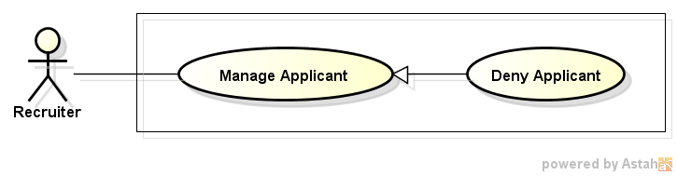

Figure 36: Deny Applicant

###### Use case description

|  |  |  |  |
| --- | --- | --- | --- |
| **USE CASE –031** | | | |
| **Use Case No.** | 031 | **Use Case Version** | 1.0 |
| **Use Case Name** | Deny Applicant | | |
| **Author** | Vo Hoan Thien | | |
| **Date** | 18/05/2015 | **Priority** | High |
| **Actor:** Recruiter  **Summary:**   * Recruiter can read applicant profile and mark them as denied if that person is unsuitable for that job.   **Goal:**   * Help recruiter on manage their applicant.   **Triggers:**   * Staff clicks on “Từ chối” button.   **Preconditions:**   * User login successfully into website with role recruiter. * Applicant List Page is displayed and activating. * At least one applicant has status not equal “Đã từ chối” is displayed on data table.   **Post Conditions:**   * Accept status is updated in database. * Status of updated applicant is changed into “Đã từ chối”.   **Main Success Scenario:**   |  |  |  | | --- | --- | --- | | Step | Actor Action | System Response | | 1 | From applicant list, user clicks on “Từ chối” button. | Confirm dialog “Bạn có chắc muốn từ chối hồ sơ này?” is displayed. | | 2 | User click on “Đồng ý” button. | - The data table is refreshed.  - At the selected applicant row:  + Status is changed into “Đã từ chối”.  + “Từ chối” button is disappeared.  + “Chấp nhận” button is displayed. |   **Alternative Scenario:**   |  |  |  | | --- | --- | --- | | No. | Actor Action | System Response | | 1 | After step 2, user clicks on “Hủy” button. | - Confirm dialog is close.  - Applicant List Page is reactivated. |   **Exceptions:**   |  |  |  | | --- | --- | --- | | No. | Actor Action | System Response | | 1 | At step 2, applicant is already cancel apply request. | - Validation message: “Đã có lỗi xảy ra trong quá trình cập nhật thông tin, vui lòng thử lại sau” is displayed.  - Applicant List Page is refreshed. |   **Relationships:**  N/A  **Business Rules:**   * Accepted applicant could be deny, and the same for denied applicant. | | | |

##### Create Company Info

###### Use case diagram

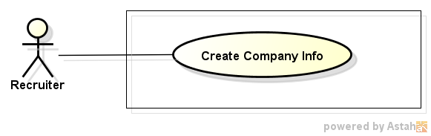

Figure 37: Create Company Info

###### Use case description

|  |  |  |  |
| --- | --- | --- | --- |
| **USE CASE –032** | | | |
| **Use Case No.** | 032 | **Use Case Version** | 1.0 |
| **Use Case Name** | Create Company Info | | |
| **Author** | Vo Hoan Thien | | |
| **Date** | 18/05/2015 | **Priority** | Normal |
| **Actor:** Recruiter  **Summary:**   * Recruiter can create company information in order to introduce to user about their company.   **Goal:**   * Allow recruiter to create company information.   **Triggers:**   * Recruiter clicks on login avatar on navigation bar and select “Tạo thông tin công ty” item.   **Preconditions:**   * User login to website successfully with role recruiter. * Navigation bar is displayed and activating.   **Post Conditions:**   * Successful:   + Company information is created and added into database.   + Successful message is displayed to user.   + User can review their company information. * Failed:   + Nothing is added to database.   + Error message is displayed to user.   **Main Success Scenario:**   |  |  |  | | --- | --- | --- | | Step | Actor Action | System Response | | 1 | User clicks on login avatar on navigation bar and select “Tạo thông tin công ty” item. | Create company information from is displayed. | | 2 | User inputs valid data to all required field in the company info create form. | All input data is displayed correctly on the form with no validation error message. | | 3 | User click on “Tạo” button on the form. | Successful message: “Tạo thông tin công ty thành công” is displayed. | | 4 | User click on “Đồng ý” button. | - Successful message is closed.  - Company Detail Page is displayed. |   **Alternative Scenario:**   |  |  |  | | --- | --- | --- | | No. | Actor Action | System Response | | 1 | At step 3, user clicks on “Hủy” button. | Redirect user to Index Page. |   **Exceptions:**   |  |  |  | | --- | --- | --- | | No. | Actor Action | System Response | | 1 | User input invalid data or not input n any required filed in the job create form. | Validation message is displayed for any error right next to the input data field. |   **Relationships:**  N/A  **Business Rules:**   * Company information is created with public status equal “false”. | | | |

##### Update Company Info

###### Use case diagram

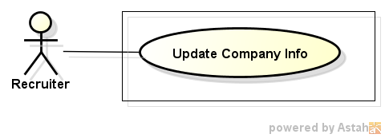

Figure 38: Update Company Info

###### Use case description

|  |  |  |  |
| --- | --- | --- | --- |
| **USE CASE –033** | | | |
| **Use Case No.** | 033 | **Use Case Version** | 1.0 |
| **Use Case Name** | Update Company Profile | | |
| **Author** | Tran Chung Thanh | | |
| **Date** | 18/05/2015 | **Priority** | High |
| **Actor:**  Recruiter  **Summary:**  In this case, recruiters can manage company profile  **Goal:**  Recruiter can update company profile successfully  **Triggers:**  Recruiter click on “Quản Lý Thông Tin Công Ty” tab in recruiters home page  **Preconditions:**  Recruiter has already logged in  **Post Conditions:**  Redirect user to the company profile page  **Main Success Scenario:**   |  |  |  | | --- | --- | --- | | Step | Actor Action | System Response | | 1 | Recruiter click on “Quản Lý Thông Tin Công Ty” button in recruiters home page | Manage company profiles page will be displayed | | 2 | Recruiter click on “Cập Nhật Thông Tin Công Ty” button | Recruiter can re-fill or update new info of the company | | 3 | Recruiter fill all info of company in all text box |  | | 4 | Recruiter click on “Lưu” button | Show message : “Bạn đã cập nhật thành thông tin công ty thành công” | | 5 | Recruiter click on “OK” button or close message | Redirect recruiter to the company profile page |   **Alternative Scenario:**   |  |  |  | | --- | --- | --- | | Step | Actor Action | System Response | | 1 | Recruiter click on “Quản Lý Thông Tin Công Ty” button in recruiters home page | Manage company profiles page will be displayed | | 2 | Recruiter click on “Cập Nhật Thông Tin Công Ty” button | Recruiter can re-fill or update new info of the company | | 3 | Recruiter fill all info of company in all text box |  | | 4 | Recruiter click on “Hủy” button | Redirect recruiter to the company profile page |   **Exceptions:**   |  |  |  | | --- | --- | --- | | Step | Actor Action | System Response | | 1 | Recruiter click on “Quản Lý Thông Tin Công Ty” button in recruiters home page | Manage company profiles page will be displayed | | 2 | Recruiter click on “Cập Nhật Thông Tin Công Ty” button | Recruiter can re-fill or update new info of the company | | 3 | Recruiter fill some info of company , but skipped some mandatory info |  | | 4 | Recruiter click on “Lưu” button | Show all required messages for all missing mandatory info | | 5 | Recruiter click on “OK” button or close message | Redirect recruiter to the company’ profiles page |   **Relationships:**  Log in use case  **Business Rules:**   * Some mandatory data fields must required * Update profile within 3 seconds | | | |

##### View Job Seeker’s Profile

###### Use case diagram

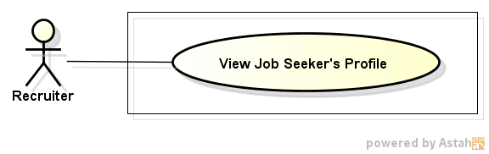

Figure 39: View Job Seeker's Profile

###### Use case description

|  |  |  |  |
| --- | --- | --- | --- |
| **USE CASE –034** | | | |
| **Use Case No.** | 034 | **Use Case Version** | 1.0 |
| **Use Case Name** | View Job Seeker’s Profile | | |
| **Author** | Vo Hoan Thien | | |
| **Date** | 18/05/2015 | **Priority** | High |
| **Actor:** Recruiter  **Summary:**   * Recruiter can view public job seeker profile in order to have more chance on recruiting high quality employee.   **Goal:**   * Help recruiter on recruiting process.   **Triggers:**   * Recruiter selects one profile on the profile list.   **Preconditions:**   * User login successfully into website with role recruiter. * Profile List Page (also Applicant List Page) is displayed and activating. * At least one profile is created and existed on database.   **Post Conditions:**   * Profile Detail Page is displayed and activating. * All information in the profile is displayed to recruiter.   **Main Success Scenario:**   |  |  |  | | --- | --- | --- | | Step | Actor Action | System Response | | 1 | User selects one profile on the profile list. | - Profile Detail Page is displayed and activating.  - All information in the profile is displayed. |   **Alternative Scenario:**   |  |  |  | | --- | --- | --- | | No. | Actor Action | System Response | | 1 | At step 1, the profile is disabled at the same time. | - Profile List Page is displayed and activating.  - Message “Bạn không thể xem được hồ sơ vào lúc này!”. |   **Exceptions:**  N/A  **Relationships:**  N/A  **Business Rules:**  N/A | | | |

#### <Manager> Overview Use case

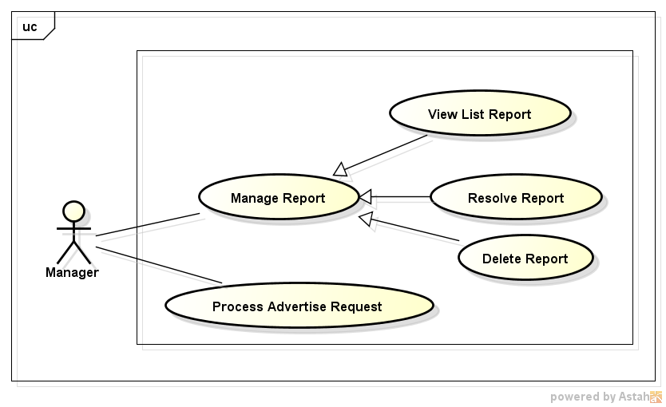

Figure 40: Manager - Overview Use Case

##### View List Report

###### Use case diagram

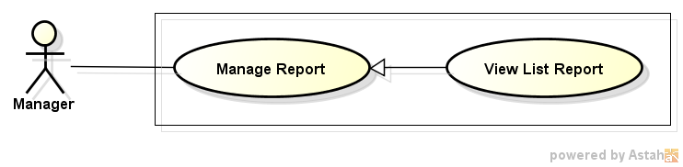

Figure 41: View List Report

###### Use case description

|  |  |  |  |
| --- | --- | --- | --- |
| **USE CASE –035** | | | |
| **Use Case No.** | 035 | **Use Case Version** | 1.0 |
| **Use Case Name** | View List Report | | |
| **Author** | Pham Quoc Thai | | |
| **Date** | 20/05/2015 | **Priority** | High |
| **Actor:** Manager, Staff, Administrator  **Summary:**  In this case, admin can view problem report list.  **Goal:**  All problem reports display successfully.  **Triggers:**  Click on tab "Danh sách báo cáo lỗi" on Admin Home page.  **Preconditions:**  Admin must login into website.  **Post Conditions:**  N/A  **Main Success Scenario:**   |  |  |  | | --- | --- | --- | | Step | Actor Action | System Response | | 1 | Click on tab "Danh sách báo cáo lỗi" on Admin Home page. | All problem report s display successfully. |   **Alternative Scenario:**  N/A  **Exceptions:**  N/A  **Relationships:**  N/A  **Business Rules:**  N/A | | | |

##### Resolve Report

###### Use case diagram

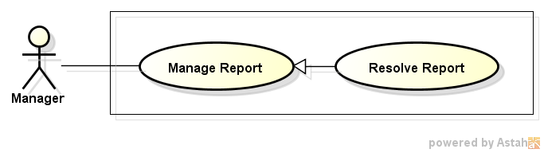

Figure 42: Resolve Report

###### Use case description

|  |  |  |  |
| --- | --- | --- | --- |
| **USE CASE –036** | | | |
| **Use Case No.** | 036 | **Use Case Version** | 1.0 |
| **Use Case Name** | Resolve Report | | |
| **Author** | Vo Hoan Thien | | |
| **Date** | 18/05/2015 | **Priority** | High |
| **Actor:** Manager, Staff, Administrator  **Summary:**   * Manager, staff and administrator could change the report status into resolve after having the report fixed.   **Goal:**   * Help manager, staff, and administrator on manage problem report.   **Triggers:**   * User clicks on “Đã xử lý” button.   **Preconditions:**   * User login successfully into website with role manager, staff, or administrator. * Report List Page is displayed and activating. * At least one report has status “Chưa xử lý” is displayed on data table.   **Post Conditions:**   * Resolve status is updated in database. * Status of updated applicant is changed into “Đã xử lý”.   **Main Success Scenario:**   |  |  |  | | --- | --- | --- | | Step | Actor Action | System Response | | 1 | From report list, user clicks on “Đã xử lý” button. | Confirm dialog “Bạn có chắc là đã xử lý vấn đề này?” is displayed. | | 2 | User click on “Đồng ý” button. | - The data table is refreshed.  - At the selected applicant row:  + Status is changed into “Đã xử lý”.  + “Đã xử lý” button is disappeared.  + “Chưa xử lý” button is displayed. |   **Alternative Scenario:**   |  |  |  | | --- | --- | --- | | No. | Actor Action | System Response | | 1 | After step 2, user clicks on “Hủy” button. | - Confirm dialog is close.  - Report List Page is reactivated. |   **Exceptions:**   |  |  |  | | --- | --- | --- | | No. | Actor Action | System Response | | 1 | At step 2, applicant is already cancel apply request. | - Validation message: “Đã có lỗi xảy ra trong quá trình cập nhật thông tin, vui lòng thử lại sau” is displayed.  - Report List Page is refreshed. |   **Relationships:**  N/A  **Business Rules:**   * Resolved report could be bring back to not resolved, and the same for the report that has not been resolved. | | | |

##### Delete Report

###### Use case diagram

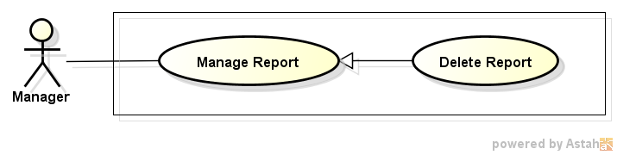

Figure 43: Delete Report

###### Use case description

|  |  |  |  |
| --- | --- | --- | --- |
| **USE CASE –037** | | | |
| **Use Case No.** | 037 | **Use Case Version** | 1.0 |
| **Use Case Name** | Delete Problem Report | | |
| **Author** | Pham Quoc Thai | | |
| **Date** | 20/05/2015 | **Priority** | High |
| **Actor:** Manager, Staff, Administrator  **Summary:**  In this case, administrator can delete of specific problem report.  **Goal:**  Problem report can be deleted successfully.  **Triggers:**  Click on “Xóa” link of specific problem report on Problem Report List page.  **Preconditions:**  Admin must login into website.  **Post Conditions:**  N/A  **Main Success Scenario:**   |  |  |  | | --- | --- | --- | | Step | Actor Action | System Response | | 1 | Click on “Xóa” link of specific problem report on Problem Report List page. | Show pop up confirm. | | 2 | Click button "Xác Nhận" | Problem report has been deleted. | | Click button "Hủy" | Close pop up and return Problem Report List page. |   **Alternative Scenario:**  N/A  **Exceptions:**  N/A  **Relationships:**  N/A  **Business Rules:**  N/A | | | |

##### Process Advertise Request

###### Use case diagram

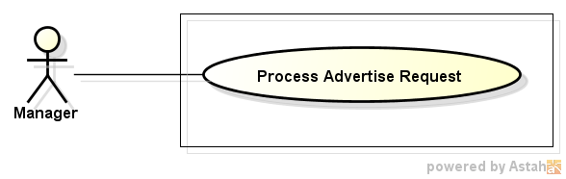

Figure 44: Process Advertise Request

###### Use case description

|  |  |  |  |
| --- | --- | --- | --- |
| **USE CASE –038** | | | |
| **Use Case No.** | 038 | **Use Case Version** | 1.0 |
| **Use Case Name** | Approve Adveriise Package Request | | |
| **Author** | Nguyen Ngoc Thien | | |
| **Date** | 20/05/2015 | **Priority** | High |
| **Actor:**   * Manager.   **Summary:**   * In this case, managercan approve advertise package request from recruiter.   **Goal:**   * Aprove advertise package request successfully   **Triggers:**   * Click on item “Quản lý yêu cầu mua góiquảng cáo” on dropdown menu of manager.   **Preconditions:**   * Login successfully with role Manager   **Post Conditions:**   * Job advertise requests are approved   **Main Success Scenario:**   |  |  |  | | --- | --- | --- | | Step | Actor Action | System Response | | 1 | Click on item "Quản lý yêu cầu mua gói quảng cáo" on dropdown menu of manager. | Redirect to “Quản lý yêu cầu mua gói quảng cáo” page contains:   * “Chấp nhận nhiều” button and “Từ chối nhiều” button * Search textbox and “Tìm kiếm” button * A list of advertise package request .Each line has checkbox, recruiter’s username, advertise package name, quantity, “Chấp nhận” button, “Từ Chối” button | | 2 | Check on checkboxes in whichwant to approve then click “Chấp nhận nhiều” button | Searh in database those advertise package request and changes status to approve, then reload page |   **Alternative Scenario:**   |  |  |  | | --- | --- | --- | | Step | Actor Action | System Response | | 1 | Click “Chấp nhận” button on every line of record which want to approve | Approve that advertise package requests |   **Exceptions:**   |  |  |  | | --- | --- | --- | | Step | Actor Action | System Response | | 1 | Don’t tick any checkboxes click “Chấp nhận” button | Display alert “Vui lòng chọn các yêu cầu mua gói quảng cáo bạn muốn chấp nhạn” |   **Relationships:**   * Login use case   **Business Rules:**   * Manager only approve when recruiter transfer enough money for those request | | | |

#### <Staff> Overview Use case

##### View List Report

This function has been specified before. (Reference UC-035, Manager – View List Report 3.2.2.3.1)

##### Resolve Report

This function has been specified before. (Reference UC-036, Manager – Resolve Report 3.2.2.3.2)

##### Delete Report

This function has been specified before. (Reference UC-037, Manager – Delete Report 3.2.2.5.3)

##### Process Job Package Request

###### Use case diagram

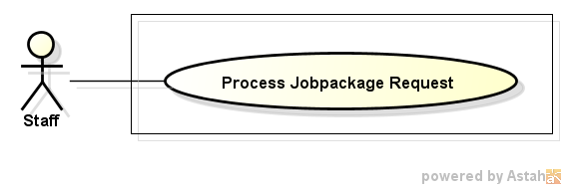

Figure 45: Process Job Package Request

###### Use case description

|  |  |  |  |
| --- | --- | --- | --- |
| **USE CASE –039** | | | |
| **Use Case No.** | 039 | **Use Case Version** | 1.0 |
| **Use Case Name** | Process Job Package Request | | |
| **Author** | Nguyen Ngoc Thien | | |
| **Date** | 20/05/2015 | **Priority** | High |
| **Actor:**   * Manager.   **Summary:**   * In this case, manager can approve job package request from recruiter.   **Goal:**   * Approve job package request successfully.   **Triggers:**   * Click on item “Quản lý yêu cầu mua gói công việc” on dropdown menu of manager.   **Preconditions:**   * Login successfully with role Manager   **Post Conditions:**   * Job package requests are approved   **Main Success Scenario:**   |  |  |  | | --- | --- | --- | | Step | Actor Action | System Response | | 1 | Click on item "Quản lý yêu cầu mua gói công việc" on dropdown menu of manager. | Redirect to “Quản lý yêu cầu mua gói công việc” page contains:   * “Chấp nhận nhiều” button and “Từ chối nhiều” button * Search textbox and “Tìm kiếm” button * A list of job package request .Each line has checkbox, recruiter’s username, job package name, quantity, “Chấp nhận” button, “Từ Chối” button | | 2 | Check on checkboxes in whichwant to approve then click “Chấp nhận nhiều” button | Searh in database those job package request and changes status to approve, then reload page |   **Alternative Scenario:**   |  |  |  | | --- | --- | --- | | Step | Actor Action | System Response | | 1 | Click “Chấp nhận” button on every line of record which want to approve | Approve that job package requests |   **Exceptions:**   |  |  |  | | --- | --- | --- | | Step | Actor Action | System Response | | 1 | Don’t tick any checkboxes click “Chấp nhận” button | Display alert “Vui lòng chọn các yêu cầu mua gói công việc bạn muốn chấp nhạn” |   **Relationships:**   * Login use case   **Business Rules:**   * Manager only approve when recruiter transfer enough money for those request | | | |

##### Approve Topic

###### Use case diagram

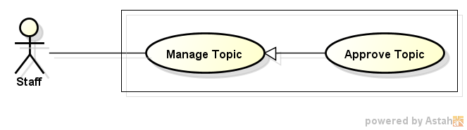

Figure 46: Approve Topic

###### Use case description

|  |  |  |  |
| --- | --- | --- | --- |
| **USE CASE –040** | | | |
| **Use Case No.** | 040 | **Use Case Version** | 1.0 |
| **Use Case Name** | Approve Topic | | |
| **Author** | Vo Hoan Thien | | |
| **Date** | 18/05/2015 | **Priority** | Normal |
| **Actor:** Staff  **Summary:**   * Topic must get approval from staff in order to be public.   **Goal:**   * Allow staff to check information of any topic on website before going public.   **Triggers:**   * Staff clicks on “Duyệt” button.   **Preconditions:**   * User login successfully into website with role staff. * Pending List Page is displayed and activating. * At least one topic has approval status not equal “1” (meaning approved) exist on database.   **Post Conditions:**   * Approve status is updated in database. * Status of updated topic is changed into “Đã duyệt”.   **Main Success Scenario:**   |  |  |  | | --- | --- | --- | | Step | Actor Action | System Response | | 1 | From pending list, user clicks on “Duyệt” button. | Confirm dialog “Bạn có chắc muốn duyệt bài viết này?” is displayed. | | 2 | User click on “Duyệt” button. | - The data table is refreshed.  - At the selected topic row:  + Status is changed into “Đã duyệt”.  + “Duyệt” button is disappeared.  + “Từ chối” button is displayed. |   **Alternative Scenario:**   |  |  |  | | --- | --- | --- | | No. | Actor Action | System Response | | 1 | After step 2, user clicks on “Hủy” button. | - Confirm dialog is close.  - Pending List Page is reactivated. |   **Exceptions:**   |  |  |  | | --- | --- | --- | | No. | Actor Action | System Response | | 1 | At step 2, update topic is already deleted. | - Validation message: “Đã có lỗi xảy ra trong quá trình cập nhật thông tin, vui lòng thử lại sau” is displayed.  - Pending List Page is refreshed. |   **Relationships:**  N/A  **Business Rules:**   * Approved Topic could be deny, and the same for denied topic. | | | |

##### Disapprove Topic

###### Use case diagram

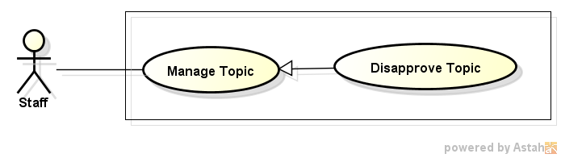

Figure 47: Disapprove Topic

###### Use case description

|  |  |  |  |
| --- | --- | --- | --- |
| **USE CASE –041** | | | |
| **Use Case No.** | 041 | **Use Case Version** | 1.0 |
| **Use Case Name** | Disapprove Topic | | |
| **Author** | Vo Hoan Thien | | |
| **Date** | 18/05/2015 | **Priority** | Normal |
| **Actor:** Staff  **Summary:**   * Staff prevent topic which has contents inappropriate by using this function.   **Goal:**   * Allow staff to check information of any topic on website before going public.   **Triggers:**   * Staff clicks on “Từ chối” button.   **Preconditions:**   * User login successfully into website with role staff. * Pending List Page is displayed and activating. * At least one topic has approval status not equal “2” (meaning disapproved) exist on database.   **Post Conditions:**   * Approve status is updated in database. * Status of updated topic is changed into “Đã duyệt”.   **Main Success Scenario:**   |  |  |  | | --- | --- | --- | | Step | Actor Action | System Response | | 1 | From pending list, user clicks on “Từ chối” button. | Confirm dialog “Bạn có chắc không muốn duyệt bài viết này?” is displayed. | | 2 | User click on “Từ chối” button. | - The data table is refreshed.  - At the selected topic row:  + Status is changed into “Đã từ chối”.  + “Từ chối” button is disappeared.  + “Duyệt” button is displayed. |   **Alternative Scenario:**   |  |  |  | | --- | --- | --- | | No. | Actor Action | System Response | | 1 | After step 2, user clicks on “Hủy” button. | - Confirm dialog is close.  - Pending List Page is reactivated. |   **Exceptions:**   |  |  |  | | --- | --- | --- | | No. | Actor Action | System Response | | 1 | At step 2, update topic is already deleted. | - Validation message: “Đã có lỗi xảy ra trong quá trình cập nhật thông tin, vui lòng thử lại sau” is displayed.  - Pending List Page is refreshed. |   **Relationships:**  N/A  **Business Rules:**   * Approved Topic could be deny, and the same for denied topic. | | | |

##### Manage Common List

###### Use case diagram

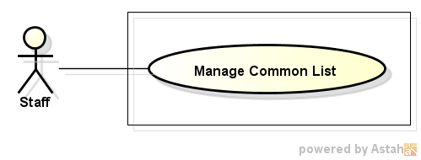

Figure 48: Manage Common List

###### Use case description

|  |  |  |  |
| --- | --- | --- | --- |
| **USE CASE –042** | | | |
| **Use Case No.** | 042 | **Use Case Version** | 1.0 |
| **Use Case Name** | Manage Common List | | |
| **Author** | Vo Hoan Thien | | |
| **Date** | 18/05/2015 | **Priority** | Normal |
| **Actor:** Staff  **Summary:**   * Allow staff to update the information of common list (City, Job Category…).   **Goal:**   * Help staff manage common list easier.   **Triggers:**   * Staff clicks on login avatar and choose “Quản lý dữ liệu chung” item.   **Preconditions:**   * User login successfully into website with role staff. * Navigation bar is displayed and activating.   **Post Conditions:**   * Successful   + Data is updated to database.   + Successful message is displayed to user. * Fail:   + Data is not updated to database.   + Error message is displayed to user.   **Main Success Scenario:**   |  |  |  | | --- | --- | --- | | Step | Actor Action | System Response | | 1 | User clicks on login avatar on navigation bar and choose “Quản lý dữ liệu chung” item. | Manage Common List Page is displayed and activating. | | 2 | - User modify data (School Level, City, Country, Job Category, …)  - User clicks on save button. | - Edit data is save to database.  - Successful message: “Cập nhật dữ liệu thành công” is displayed. |   **Alternative Scenario:**  N/A  **Exceptions:**   |  |  |  | | --- | --- | --- | | No. | Actor Action | System Response | | 1 | At step 2, user modifies data with error value (duplicated value, null…) | Validation message: “Cập nhật dữ liệu thất bại” is displayed. |   **Relationships:**  N/A  **Business Rules:**  N/A | | | |

#### <Administrator> Overview Use case

##### View List Report

This function has been specified before. (Reference UC-035, Manager – View List Report 3.2.2.3.1)

##### Resolve Report

This function has been specified before. (Reference UC-036, Manager – Resolve Report 3.2.2.3.2)

##### Delete Report

This function has been specified before. (Reference UC-037, Manager – Delete Report 3.2.2.5.3)

##### View List Account

###### Use case diagram

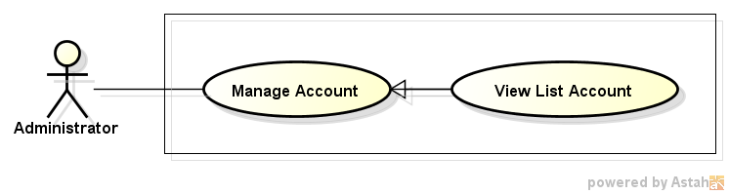

Figure 49: View List Account

###### Use case description

|  |  |  |  |
| --- | --- | --- | --- |
| **USE CASE –043** | | | |
| **Use Case No.** | 043 | **Use Case Version** | 1.0 |
| **Use Case Name** | View List Account | | |
| **Author** | Pham Quoc Thai | | |
| **Date** | 20/05/2015 | **Priority** | High |
| **Actor:**   * Administrator.   **Summary:**  In this case, admin can view account list and search account.  **Goal:**  All account display successfully.  **Triggers:**  Click on tab "Danh sách tài khoản" on Admin Home Page.  **Preconditions:**  Admin must login into website.  **Post Conditions:**  N/A  **Main Success Scenario:**   |  |  |  | | --- | --- | --- | | Step | Actor Action | System Response | | 1 | Click on tab " Danh sách tài khoản " on Admin home page. | All accounts display successfully. | | 2 | Input to Search textbox | System will show all accounts into list which their information contains the input keyword. |   **Alternative Scenario:**  N/A  **Exceptions:**  N/A  **Relationships:**  N/A  **Business Rules:**  N/A | | | |

##### Search Account

###### Use case diagram

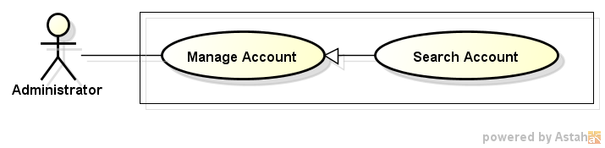

Figure 50: Search Account

###### Use case description

|  |  |  |  |
| --- | --- | --- | --- |
| **USE CASE –044** | | | |
| **Use Case No.** | 044 | **Use Case Version** | 1.0 |
| **Use Case Name** | Search Account | | |
| **Author** | Vo Hoan Thien | | |
| **Date** | 18/05/2015 | **Priority** | Normal |
| **Actor:** Administrator  **Summary:**   * Allow administrator to create account for staff and manager.   **Goal:**   * Only administrator can create account for staff and manager.   **Triggers:**   * Administrator enters key word into text box and click on “Tìm kiếm” button.   **Preconditions:**   * User login successfully into website with role admin. * Manage Account Page is displayed and activating. * List of account is displayed with one or more result.   **Post Conditions:**   * Show the accounts which have their user name contain key word. * If no matching result, show the inform message to user.   **Main Success Scenario:**   |  |  |  | | --- | --- | --- | | Step | Actor Action | System Response | | 1 | User inputs keyword into text box, then click on “Tìm kiếm” button. | - Data table is refreshed.  - Accounts which their username contain the key word is displayed on the table. |   **Alternative Scenario:**   |  |  |  | | --- | --- | --- | | No. | Actor Action | System Response | | 1 | User inputs keyword that is not existed on any username | - The table is not displayed.  - Message: “Không tìm thấy tài khoản tương tự” is displayed. |   **Exceptions:**  N/A  **Relationships:**  N/A  **Business Rules:**   * This search function only looking for the topics with the title contain the entered key words. | | | |

##### Create Account

###### Use case diagram

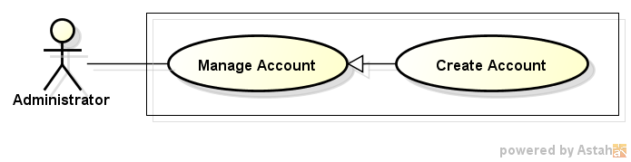

Figure 51: Create Account

###### Use case description

|  |  |  |  |
| --- | --- | --- | --- |
| **USE CASE –045** | | | |
| **Use Case No.** | 045 | **Use Case Version** | 1.0 |
| **Use Case Name** | Create Account | | |
| **Author** | Pham Quoc Thai | | |
| **Date** | 20/05/2015 | **Priority** | High |
| **Actor:**   * Administrator.   **Summary:**  In this case, admin can create new account.  **Goal:**  New account can be created.  **Triggers:**  Click button "Tạo mới tài khoản " on Account List page.  **Preconditions:**  Admin must login into website.  **Post Conditions:**  N/A  **Main Success Scenario:**   |  |  |  | | --- | --- | --- | | Step | Actor Action | System Response | | 1 | Click button "Tạo mới tài khoản " on Account List page. | Show Create New Account Page. | | 2 | Enter “Tên Tài Khoản”, “Thư Mail”, and “Mật Khẩu”, choose type account after that click Button “Tạo Mới”. | New account added into database. |   **Alternative Scenario:**  N/A  **Exceptions:**  N/A  **Relationships:**  N/A  **Business Rules:**  N/A | | | |

##### Delete Account

###### Use case diagram

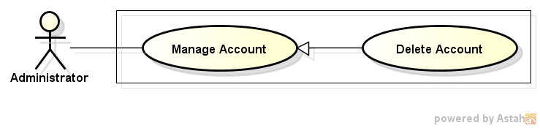

Figure 52: Delete Account

###### Use case description

|  |  |  |  |
| --- | --- | --- | --- |
| **USE CASE –046** | | | |
| **Use Case No.** | 046 | **Use Case Version** | 1.0 |
| **Use Case Name** | Delete account | | |
| **Author** | Pham Quoc Thai | | |
| **Date** | 20/05/2015 | **Priority** | High |
| **Actor:**   * Administrator.   **Summary:**  In this case, administrator can delete of specific account.  **Goal:**  Account can be deleted successfully.  **Triggers:**  Click on “Xóa tài khoản” link of specific account on Account List page.  **Preconditions:**  Admin must login into website.  **Post Conditions:**  N/A  **Main Success Scenario:**   |  |  |  | | --- | --- | --- | | Step | Actor Action | System Response | | 1 | Click on “Xóa tài khoản” link of specific account on Account List page. | Show pop up confirm. | | 2 | Click button "Xác Nhận" | Account has been deleted. | | Click button "Hủy" | Close pop up and return Account List page. |   **Alternative Scenario:**  N/A  **Exceptions:**  N/A  **Relationships:**  N/A  **Business Rules:**  N/A | | | |

### Non-functional Requirement

#### Reliability

* All the transactions are managed by staff.
* System can perform roll back transaction when errors occurring

#### Availability

* The system can only run with network connection.
* All the functions can be used every time exclude maintenance time.

#### Security

* Allow user to update account information and change their account password.
* Each role of user has a specific permission to interact with system.
* System always checks authorization and authentication before doing anything.

#### Maintainability

* The system is easy to updated or modified, required maintenance time at most 8 hours.
* Data will be backed up once every two weeks.

#### Portability

* The system could be moved to another platform like Android or IOS with 50% module of modules that need changing, with 6 people per 2 months and a half.

#### Performance

* The functions in website must be response in around 3 seconds.

## Entity Relationship Diagram

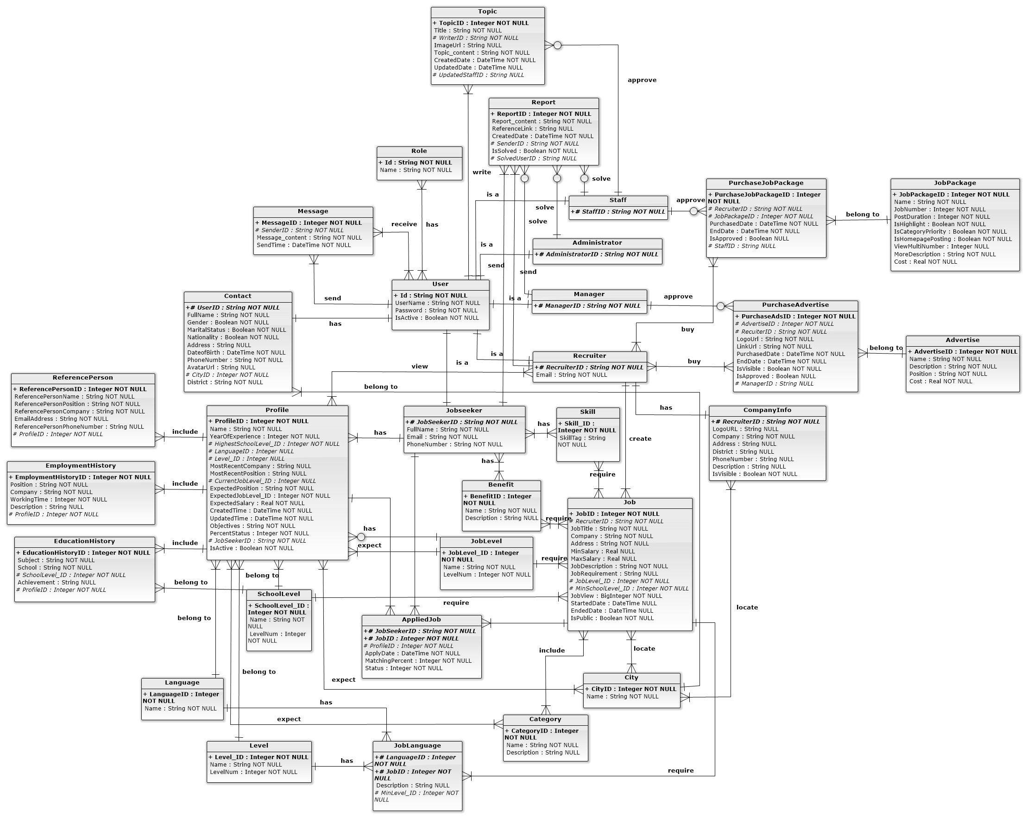

Figure 53: Entity Relationship Diagram